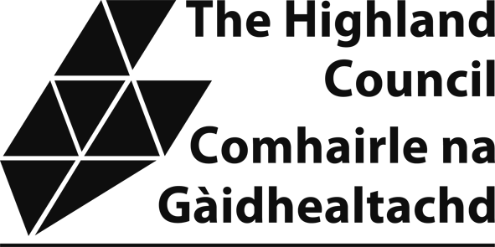

NON-DOMESTIC RATES: APPLICATION FOR UNOCCUPIED RELIEF FOR NON-COMMERCIAL SHOOTINGS

Explanatory note
From 1 April 2017, shooting rights were re-entered in the non domestic valuation roll under the terms of Land Reform Act 2016. If no commercial shooting/stalking takes place on the shooting land, unoccupied relief may be granted.
An application to the council from, or on behalf of, the ratepayer is required.
Ratepayer/business name:

Email: Telephone:

Property address (including postcode):

Property reference number (on the rates bill):

Do you offer shooting/stalking on the land to paying participants?

Signed:

Please be aware that in signing this form you are declaring that the information provided is correct and complete. If you provide information that is wrong incomplete or fail to report a change which may affect your relief you may be prosecuted.

DECLARATION
I declare that the information provided on this form is true, complete and correct. I understand that if I give information that is wrong, incomplete or fail to report a change, which may affect my relief, I may be prosecuted.
A privacy notice explaining how The Highland Council manages your information for the purpose of collecting non domestic rates and administering rates reliefs is detailed here: www.highland.gov.uk/privacy-Non_domestic_rates_payments
Please tick this box to confirm that you have read the privacy notice. ☐

Company Name and stamp (if applicable): | Applicant’s Full Name: Print:  Sign:
Position held:
Date:

IMPORTANT: Before posting this form to Non Domestic Rates, The Highland Council, PO Box 5650, Inverness, IV3 5YX, please check the following:
- Have you included all requested documentation?
- Have you read, fully understood and signed the declaration above?

If you need assistance or additional information please contact the Non Domestic Rates Team by telephoning 01463 702984 or by emailing nondomesticrates@highland.gov.uk. Please do NOT send personal data to this email address.

