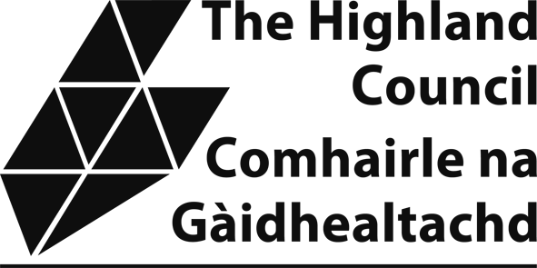

Enterprise Area Relief Scheme

The Highland Council Application Form
The Non-Domestic Rates (Enterprise Areas) (Scotland) Regulations 2016 and subsequent amendments will provide non-domestic rates relief to businesses concerned with specific sectors in defined geographic Enterprise Areas until 31 March 2026.
The Enterprise areas in the Highlands are:
- Life Sciences Enterprise Area - Inverness Campus

Low Carbon / Renewables North Enterprise Area - Scrabster
Eligible businesses must be undertaking specified activities within the Enterprise Areas. Further information regarding the scheme including the specified activities can be found using the following link to the Scottish Government’s website:
www.scotland.gov.uk/Topics/Government/local-government/17999/11199/resources
Only new build properties or properties which have been vacant for at least a three month period are eligible for rates relief.
The level of relief available depends on the rateable value of your business, eligible property and is set out in the table below:

Rateable value | Percentage of rates relief
 | Up to 31 March 2024 | 2024/25 | 2025/26
£120,000 or less | 100% | 66.7% | 33.%
More than £120,000 but not exceeding  £240,000 | 50% | 33.3% | 16.7%
More than £240,000 but not exceeding  £480,000 | 25% | 16.7% | 8.3%
More than £480,000 but not exceeding  £1,200,000 | 10% | 6.7% | 3.3%
More than £1,200,000 but not exceeding £2,400,000 | 5% | 3.3% | 1.7%
More than £2,400,000 | 2.5% | 1.7% | 0.8%

Section 1 | Property Details

Subject (property) Address:
Reference No (from your bill):
Rateable Value:
Date of occupation:
Is the property new build? Yes / No

If property is an existing build, was it vacant for at least 3 months prior to occupation? Yes / No

Describe fully all business activity which is/will be carried out at the above property address:

…..……………………………………………………………………………………………………………..

………………………………………………………………………………………………………………….

………………………………………………………………………………………………………………….

Section 2 | Applicant Details

Applicant Name (business/company name) and contact address:
Telephone Number:
Email address:

Section 3 | Change in Circumstances

It is your duty to inform The Highland Council and if appropriate, other Council(s) of any change in circumstances which may affect your eligibility for this scheme.

Help us to help you. Please enter a daytime telephone number, this will allow us to contact you speedily if we need further information:

Daytime Telephone: ………………………………………………………………………………………

Please provide us with a contact name in your organisation:

Designation: ………………………………………………………………………………………………. Name: ……………………………………………………………………………………………………… Email: ……………………………………………………………………………………………………… Company website: ………………………………………………………………………………………..

Subsidy Rules under the Subsidy Control Act 2022
Some reliefs are affected by subsidy control rules.

This relief may be offered as a Minimum Financial Assistance (MFA) subsidy under section 36 (1) of the Subsidy Control Act 2022. MFA is capped at a maximum of £315,000 over a three-period – cumulated over the current and previous two financial years.
To ensure that The Highland Council complies with the subsidy regime, it may be required to cap relief at the MFA maximum limit. This may depend on:
- the level of other public sector assistance received by your entity
- whether or not you have an interest in any business with other properties is in receipt, or eligible, for one of the existing rate relief schemes

NOTE: not all grants or reliefs are considered to be capped in this way.

You must consider whether you have already received support from any public sector body in the current financial year and the two financial years immediately preceding this. The Highland Council will determine this from the completed Subsidy Information Declaration Form.

Have you (i.e. your business/es) received public sector assistance over the last 3 years* that in total would exceed £315,000, or would you expect to exceed that threshold if this relief were granted to you? (*current and previous two accounting years of your business/es)
Yes ☐ ☐ No
IF YES, please complete a Subsidy Information Declaration Form (as enclosed).

You are required to keep a written record of the amount of any MFA received, and the date/s when it was received, for at least three years from the date it was given. Any award of MFA exceeding £100,000 is subject to transparency requirements and will be published.

SECTION 5 – DECLARATION

Please read this declaration carefully before you sign and date it.

- I am, or am duly authorised by, the Ratepayer to make the application.
- I declare that the information given on this form is correct and complete to the best of my knowledge.
- I authorise The Highland Council to make any necessary enquiries to check the information.
- I authorise The Highland Council to cross-check the information with other Councils in Scotland.

- I undertake to advise The Highland Council of any change of circumstances, including the occupation / vacation of any other property I may occupy in Scotland which may affect liability for Non-Domestic Rates Relief.
- I understand that if I give information that is incorrect or incomplete or fail to report changes in circumstances, I (or the Ratepayer I represent) may be prosecuted.
- I understand that The Highland Council will reclaim any incorrectly awarded Non-Domestic Rates Relief. I have read and understand the privacy notice here:
www.highland.gov.uk/privacy-Non_domestic_rates_payments I claim the above relief from non-domestic rates liability.
Applicant Name:

Capacity (e.g. Owner; Tenant; Agent; Employee): E-mail Address:

Contact Address:

Telephone Number:

Your
Signature: Date:

IMPORTANT: Before sending this form to Non Domestic Rates, The Highland Council, PO Box 5650, Inverness, IV3 5YX, please check the following:
- Have you included all requested documentation?
- Have you read, fully understood and signed the declaration above?

If you need assistance or additional information please contact the Non Domestic Rates Team by telephoning 01463 702984 or by emailing nondomesticrates@highland.gov.uk. Please do NOT send personal data to this email address.

