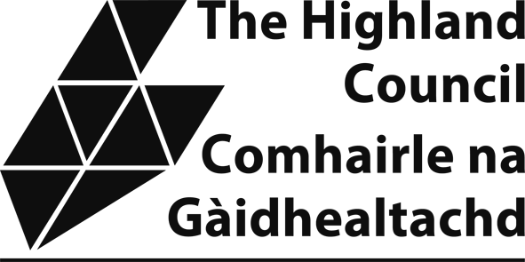

NON-DOMESTIC RATES: NEW AND IMPROVED RELIEF

Explanatory note
New and improved relief is granted under the terms of The Non Domestic Rates (New and Improved Properties) (Scotland) Regulations 2018 and subsequent amendments.

Rates relief can be awarded to properties newly entered on the valuation roll and to properties that have had improvements carried out.

Qualifying conditions:
New entry property – completely new entry entered in roll. The new
property cannot be part of an entry previously shown on the roll, previously have been shown in the Council Tax List, or previously have been exempt from valuation, for example agricultural property.

Property improvements – subjects which are shown in an existing entry for which there is an increase in rateable value caused by the refurbishment, expansion or alteration of one or more of the buildings in the entry or a concurrent change of use. The increase in rateable value cannot be caused by the combination, division or reorganisation of any subject that was shown in a different entry.
Relief levels –

New entries that are vacant when they appear on the roll receive 100% relief while the
property is empty for a period of up to four years.

New entries that are occupied when they first appear in the roll or are vacant but then become occupied will receive 100% relief for 12 months from the first date of occupation.
Improvement relief can be awarded when a property is empty or occupied. Ratepayers can apply for this relief for each increase in rateable value.
Improvement relief restricts the rates payable to the level payable prior to any increase in rateable value. Please note the relief is 100% of the increase in rates but does not negate the full rates liability. Relief of the increase in rates is granted for 12 months.

Relief must be applied for by completion of an application form.

Section 1 - Your details:

Ratepayer/business name:

Correspondence address:

Email: Telephone:

Section 2 - Property for which relief is being applied:

Property address (including postcode):

Property Reference number (on your rates bill):

Payment Reference number (on your rates bill):

Section 3 - Relief being applied for:
If applying for new entry relief please complete Section 3a.

If applying for improved property relief please complete Section 3b.

Section 3a – New entry relief
On what date was the property entered on the valuationroll?
Is the property a completely new property that was not previously part of another entry in the valuation roll? YES/N0 (delete as appropriate)
Is the property currently occupied: YES/N0 (delete as appropriate)
If occupied, on what date was the property first occupied?

Section 3b – Improved property relief
Has the rateable value of the property increased due to an improvement? YES/N0 (delete as appropriate)
If YES, please provide the new rateable value and the effective date of the increase

Please provide a brief description of the improvements carried out at the property, please include a planning reference number if applicable.

Has any part of the improved property previously been included in a different entry in the valuation roll? YES/NO (delete as appropriate)
Is the improved property occupied? YES/NO (delete as appropriate)
Please note if the property is unoccupied you should apply for unoccupied rating relief. Application forms are available on our website: www.highland.gov.uk/nondomesticrates or by emailing the rates team at:
nondomesticrates@highland.gov.uk

DECLARATION
I declare that the information provided on this form is true, complete and correct. I understand that if I give information that is wrong, incomplete or fail to report a change, which may affect my relief, I may be prosecuted.
A privacy notice explaining how The Highland Council manages your information for the purpose of collecting non domestic rates and administering rates reliefs is detailed here: www.highland.gov.uk/privacy-Non_domestic_rates_payments
Please tick this box to confirm that you have read the privacy notice.
☐

Business name:  Email address: | Applicant’s Full Name: Print:  Sign:
Position held:
Date:
IMPORTANT: Before returning this form please check the following:
- Have you completed all relevant sections?
- Have you read, fully understood and signed the declaration above?
If you need assistance or additional information please contact the Non Domestic Rates Team by telephoning 01463 702984 or by emailing nondomesticrates@highland.gov.uk. Please do NOT send personal data to this email address.
Completed forms can be posted to Non Domestic Team Highland Council PO Box 5650 Inverness IV3 5YX or emailed to: nondomesticrates@highland.gov.uk

