

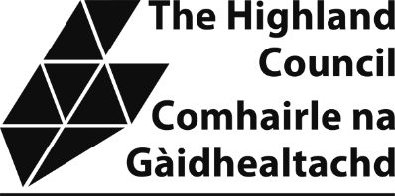
Please fill in the whole form using a ball point pen and send it to:
Non-Domestic Rates Revenues and Customer Services
PO Box 5650
Inverness IV3 5YX

Name(s) of Account Holder(s)

Bank/Building Society account number

Branch Sort Code

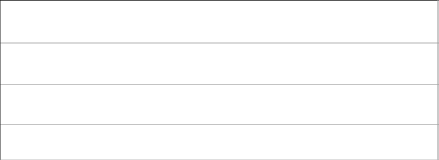
Name and full postal address of your Bank or Building Society
To: The Manager
Bank/Building Society
Address
Postcode

Instruction to your

Bank or Building Society to pay by Direct Debit
Service User Number

7 | 0 | 2 | 8 | 1 | 6
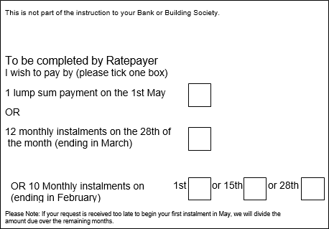

This is not part of the instruction to your Bank or Building Society.
To be completed by Ratepayer
I wish to pay by (please tick one box):
☐ 1 lump sum payment on the 1st May
OR
☐ 12 monthly instalments on the 28th of the month (ending in March)
OR
☐ 10 Monthly instalments on (ending in February)
1st ☐ or 15th ☐ or 28th ☐

Please Note: If your request is received too late to begin your first instalment in May, we will divide the amount due over the remaining months.

Instruction to your Bank or Building Society
Please pay The Highland Council Direct Debits from the account detailed in this Instruction subject to the safeguards assured by the Direct Debit Guarantee. I understand that this Instruction may remain with The Highland Council and, if so, details will be passed electronically to my Bank/Building Society.

Rates Payment Reference Number
Signature(s)
Date

Banks and Building Societies may not accept Direct Debit Instructions from some types of account

This guarantee should be detached and retained by the payer

Rates Payment Reference Number
The Direct Debit
This Guarantee is offered by all banks and building societies that accept instructions to pay Direct Debits.
If there are any changes to the amount, date or frequency of your Direct Debit The Highland Council will notify you 10 working days in advance of your account being debited or as otherwise agreed. If you request The Highland Council to collect a payment, confirmation of the amount and date will be given to you at the time of therequest.
If an error is made in the payment of your Direct Debit by The Highland Council or your bank or building society you are entitled to a full and immediate refund of the amount paid from your bank or building society.
- If you receive a refund you are not entitled to, you must pay it back when The Highland Council asks you to.
You can cancel a Direct Debit at any time by simply contacting your bank or building society. Written confirmation may be required. Please also notify us.

Important information overleaf NDR DD Mandate Mar 2022

Change of ownership, tenancy or occupancy? Have you vacated or moved into a property?
Changes should be notified immediately in writing by downloading a Change of Circumstances Form from the Council’s website at: www.highland.gov.uk/nondomesticrates. Please submit your completed and signed form to:
Non Domestic Rates Team, Revenues & Customer Services, PO Box 5650, Inverness, IV3 5YX.
Alternatively you may wish to write to us at the above address or email: nondomesticrates@highland.gov.uk. To protect the security of your data, please do not send personal or sensitive information to this email address.
For advice and information please telephone: 01463 702984.
Non Domestic Rates Small Business Bonus Scheme Are you paying too much rates?
You could receive up to 100% relief on your business rates. If you have business properties in Scotland with a combined rateable value of £35,000 or less you could qualify for relief at the following levels:
Combined rateable value of all business properties in Scotland | Percentage of Relief for 2022/23
Up to £15,000 | 100%
£15,001 to £18,000 | 25%
More than £18,000 and up to £35,000* | 25% for each property with a RV of £18,000 or under
*on each individual property with the rateable value of £18,000 or less
It’s not too late to apply for relief in respect of prior financial years. If you have not already done so, and you consider you meet the qualifying conditions you can apply online at: www.highland.gov.uk/sbbs or alternatively contact the Rates Team on telephone: 01463 702984. From 1 April 2020 Small Business Bonus is restricted to occupied properties only. Please note that both occupied and unoccupied properties must be declared on your application form.

Further information and relief application forms for Small Business Bonus and other reliefs can be found at: www.highland.gov.uk/nondomesticrates. Alternatively, pleasecontact the Rates Team as detailed in the ‘Contact Section’ on the front of your bill.

Information Fact Sheets
Fact sheets covering various aspects of non-domestic rates such as calculation of non-domestic rates, up to date relief information and ways to pay are available on our website: www.highland.gov.uk/nondomesticrates

Information for 2022/23
Retail Hospitality and Leisure Relief (RHL) – RHL relief has been extended to 2022/23. 50% relief is available to qualifying properties for the period 1 April 2022 to 30 June 2022, capped at £27,500 for each ratepayer. Further information and applications can be made here: www.highland.gov.uk/rhlar. If you are already in receipt of 100%rates relief, for example small Business bonus, you should not apply for RHL relief.

Change to payment and recovery dates for non domestic rates - Following a change to rating legislation The Highland Council is now able to initiate recovery proceedings at an earlier stage for rates due after 1 April 2021. The legislation is
available here: https://www.legislation.gov.uk/asp/2020/4/enacted.
Payment dates and amounts due are shown on your Non Domestic Rates bill.
If you are late with an instalment - The full amount of each instalment must be paid on or before the dates detailed on your bill.
.If your instalment amount is not paid by the due date detailed on your bill, you will receive a combined reminder and final notice.
If the overdue instalment amount is not fully paid within 7 days, you lose the right to pay by instalments and will have to pay the full outstanding balance for the year within a further 14 days. If the full amount is not paid as required, then we must by law obtain a Summary Warrant from the Sheriff Court to enforce payment. In doing so you will incur additional 10% costs on the outstanding amount.
If you are late with more than 2 instalments. We are only allowed to send 2 combined reminder final notices in any financial year. If you are late with a third instalment, we must send you a final notice for the full year’s outstanding Non Domestic Rates. If the full amount noted on the Final Notice is not paid by the deadline stated on the Notice, then we must by law obtain a Summary Warrant from the Sheriff Court to enforce payment. In doing so you will incur additional 10% costs on the outstanding balance.
Important changes to payment dates for ratepayers who choose to pay by an annual inst or bi-annual instalments. To align payment dates with the change in the recovery legislation, the annual payment date will be brought forward from 1 October to 1 May. The bi-annual method of payment is no longer available and those who are recorded as bi -annual payers have been switched to 10 monthly instalments. The new payments are noted on your bill. If you wish to select a different method or need payment advice, please contact the Rates Team at nondomesticrates@highland.gov.uk or telephone 01463 702984 at the earliest opportunity.

NDR DD Mandate Mar 2022

