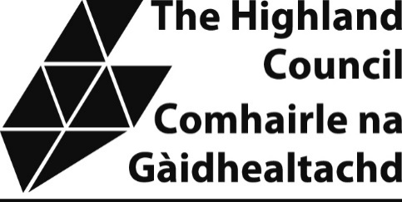

Highland Cadet Grant Scheme - Application Guidelines
What is the fund?

The Highland Council’s Cadet Grant Scheme is available all year round to benefit Cadet Detachments located solely in the Highland Council area.

Who can apply?

Any Detachment of the Army Cadets, Sea Cadets, Air Cadets or Combined Cadet Force that are solely based in the Highland Council area can apply for financial support.

What can you apply for?

  - Grants to support cadet units to take part in activities being delivered through the cadet organisation that they would not otherwise be able to afford. These include, but are not limited to:

- Battlefield Tours; Commemorative Events etc.
- UK-based Training; Annual camps, Adventurous Training or Expeditions etc.
- Overseas Training; Adventurous Training or Expeditions etc.
  - Grants for the purchase of approved, necessary equipment not normally funded by the MOD/Cadet organisation. These include, but are not limited to:
- The purchase of adventurous training equipment;
- The purchase of expedition equipment;
- The purchase of musical instruments;

  - Grants for facility enhancements. This could include, but is not limited to:

- The purchase of technology/equipment
- Sports equipment
- Fabric improvements to cadet establishments

The Council will not normally award grants where the activity or purchase has been conducted prior to the application being submitted.

How much can you apply for?

  - While there are no specified minimum or maximum grant amounts, it would not normally be the case that a grant awarded in relation to a specific application would exceed £500.

What will the conditions be?

If you are successful, you will be subject to the following general conditions. Specific conditions will be detailed in your grant award letter if required.

You will need to provide full bank details of your ACF Unit. The grant will be paid directly to the bank account of your ACF Unit.

You will be required to submit a short report outlining the impact of the grant within three months after use of the grant. The content of this may be used in the promoting the Cadet Fund and in the Council’s armed forces annual report.

If you wish to make changes to the funded activity or project, these must be agreed in advance with the Council. Failure to do so may result in the grant being withdrawn.

If the activity or project is cancelled, this may result in you needing to repay the value of the grant in full.

How can you apply?

You can apply at any time, though we recommend that you apply at least six weeks prior to the start date of your activity. This is to allow time for decision making and payment.

Complete the Highland Cadet Grant Scheme Application Form; this can be downloaded from (to be added) or obtained by email from corporatepolicy@highland.gov.uk

Cadet Detachments are not limited in the number of grant applications that can be submitted at any one time or in any given financial year.

If you have any questions about the Grant Scheme or need help completing the form, please contact corporatepolicy@highland.gov.uk

