THE COMMUNITY EMPOWERMENT (SCOTLAND) ACT 2015
NOTICE OF CONSULTATION ON THE DISPOSAL, BY LEASE AND CHANGE OF USE OF COMMON GOOD LAND.

Area of undeveloped land at the former landfill site at East Longman, Inverness IV1 1AL

The Highland Council (‘the Council’) has received a request to grant a lease and change the use of an area within common good property (‘the Property’) at the former landfill site at East Longman, Inverness (‘the Landfill Site’). Before reaching a decision, the Council must have regard to the views of Inverness residents via a consultation in terms of Section 104 Community Empowerment (Scotland) Act 2015. If following the consultation, the Council wish to agree to the request, they must seek the consent of the Sheriff Court.

What is being proposed?

Storegga Hydrogen (Cromarty) Limited propose to develop a green hydrogen production facility (‘the Development’) at an area (outlined in red on the diagram below) within the Property at the Landfill Site.

Using renewable energy sources, the Development would produce approximately 6,400 tonnes of electrolytic hydrogen annually, with production planned to play a vital role in the decarbonisation of a large industrial site within the Longman Industrial Estate. Hydrogen would also be supplied to other users. The facility could reduce carbon emissions by 45,000 tonnes of CO2e per year – equivalent to removing 32,000 fossil fuelled cars from Scotland’s roads.

The Development would include hydrogen production plant, hydrogen storage, export and transportation facilities, together with associated access roads, cabling, pipes, connections, habitat management areas and construction compounds.

Subject to the project developing as planned, the lease would commence in April 2028, with civils works and plant installation expected to be completed by August 2030. The initial lease period would be 20 years, with the option to extend the lease for a further two periods of 10 years, with a break option exercisable every 5th anniversary of commencement of the lease.

For the duration of the lease, the Inverness Common Good Fund would receive rental income representing market rates and achieving Best Value for the Fund. Prior to commencement of the Lease, the Inverness Common Good Fund would also receive an annual Option to Lease Fee, from the date of execution of the Option to Lease, until commencement of the Lease.

What land is affected?

The proposed Development (outlined in red below) is located within the former Landfill Site which is common good Property (outlined in blue below) and is situated between the foreshore of the Inner Moray Firth on the Northeast and the A9 trunk road near the A82 junction on the Southwest, Inverness.

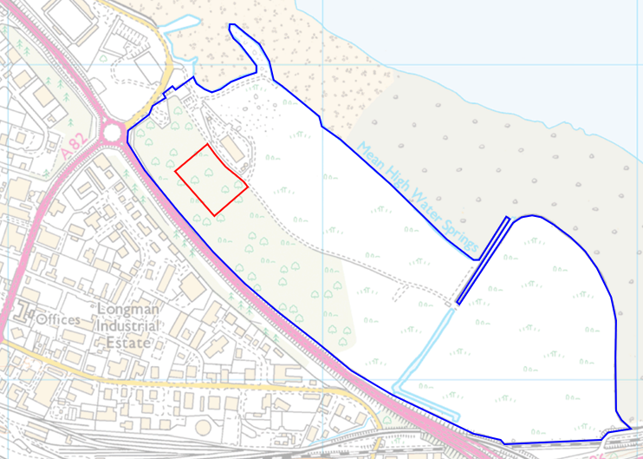
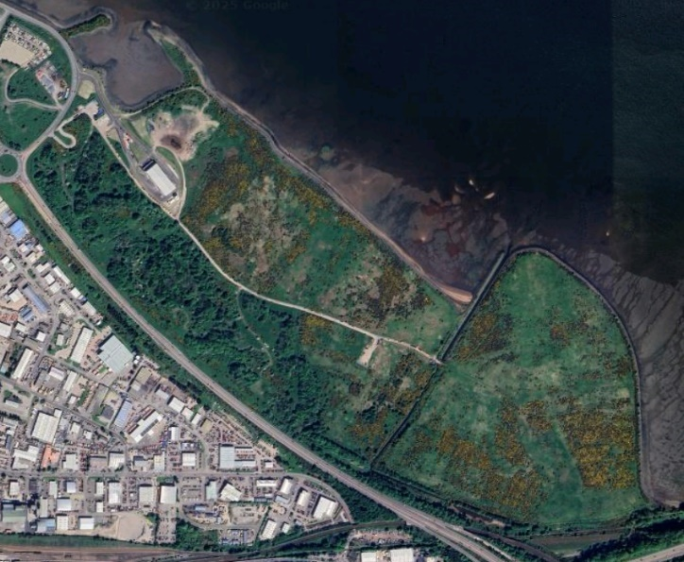

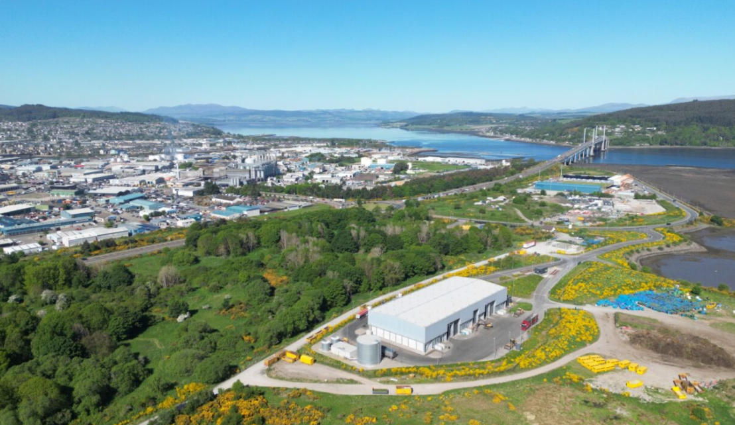

The Landfill Site is no longer used for landfill, however parts of it continue to be restricted in terms of development and public access. This statutory restriction is to enable degradation and settlement to take place and facilitate environmental monitoring. In 2022 the statutory restriction was removed in part, including over the proposed Development (outlined in red above) which is the subject of this consultation.

Representations

This consultation seeks the views of the Inverness inhabitants to inform the Council’s decision in respect of the proposal as described above to:
- Grant a lease, of common good land, and
- Change the use of common good land to permit the Development of a green hydrogen production facility.
This consultation is specifically in relation to the statutory requirements relating to common good. Should the Development proceed, further statutory consents will be required, including those related to Planning.

Key questions:

- What are your views on the proposed development utilising common good land?
- Do you have any views on potential benefits of the proposal?
- Do you have any issues or concerns arising from the
proposal?
- Do you have any additional comments?

The Council will take all representations received into account in reaching a decision.
A report of the outcome of the consultation will be presented at the City of Inverness Area Committee and a copy of the representations and responses will be published on the Council’s website.

The possible outcomes are:
- The proposal goes ahead subject to consent by the Sheriff Court.
- The proposal is amended significantly, and a fresh consultation takes place.
- The proposal does not go ahead.

Please submit written representations by email or post
- Email: common.good@highland.gov.uk
- Post: Common Good Fund Officer, Highland Council, Headquarters, Glenurquhart Road, Inverness, IV3 5NX.

Timescales

The consultation period will be open for 8-weeks commencing from 20 May 2025.
Final written representations must be received by close of play 15 July 2025.

It is anticipated that a report on the outcome of the consultation will be submitted at the City of Inverness Area Committee on 17 November 2025.

Additional Information

All Common Good property falls into one of two categories – alienable or inalienable. Alienable property can be sold, leased or have its use changed in a way that reduces public use (subject to statutory consultation). Inalienable property is also subject to statutory consultation with the additional requirement to gain court consent in terms of Section 75 Local Government (Scotland) Act 1973.

As the subjects of this consultation i.e. the Property is owned by the Council in terms of the Royal Charter of James VI dated 1591, it may be Inalienable Common Good. Therefore, if following the consultation, the Council wish to agree to the request they must apply to the Sheriff Court for consent. The court process will provide a further opportunity for the public to make representations on the proposal. A statutory advertisement will be placed in the local press to inform the public that a court process has commenced.

