
THE COMMUNITY EMPOWERMENT (SCOTLAND) ACT 2015
NOTICE OF CONSULTATION ON THE DISPOSAL AND CHANGE OF USE OF COMMON GOOD PROPERTY.

East Church Hall, Burnside Place, Cromarty IV11 8XQ

The Highland Council (‘the Council’) has received a request to dispose and change the use of East Church Hall in Cromarty which is considered to be common good property. Before reaching a decision, the Council must have regard to the views of Cromarty residents via a consultation in terms of Section 104 Community Empowerment (Scotland) Act 2015. If following the consultation, the Council wish to agree to the request they must seek the consent of the Sheriff Court.

What is being proposed?
The Cromarty Community Development Trust (‘CCDT’) has approached the Council, expressing an interest in taking on a lease of the former East Church Hall (‘the Property) with the intention of acquiring full ownership of the asset in the future. The Property is a category C Listed Building built in the 1900s as a church hall but was subsequently used as a youth club and childcare centre more recently. Since 2021/22, when the childcare service moved into the Primary School, it has lain empty with no clear future uses identified. For some time, CCDT have seen the possibilities of revitalising the Property to provide a much-needed community facility.

It is proposed to transform the Property and associated grounds into a multi-functional community hub (‘the Proposal’) with the aim of generating enough income to pay towards running costs and maintenance of the building. A business plan has been prepared, and the potential uses of the building include –
- offices, rental space and community meeting rooms;
- community café, garden, pop-up and thrift shop;
- cycling infrastructure to support active travel and to provide electric vehicle charging points.
Those who will benefit from the Proposal may include local community groups, organisations and other social enterprises; small businesses, start-ups or entrepreneurs; families, individuals and visitors to Cromarty.

The intention of the lease is to provide an interim transition period for CCDT to pilot the business model outlined in their business plan. Should the Proposal prove successful, CCDT intends to apply for a Community Asset Transfer (CAT) to acquire full ownership of the Property.

For the duration that the Property is leased to CCDT, the Cromarty Common Good Fund would receive an income representing current market rates and achieving Best Value for the fund. The lease arrangement would be for a 25-year period and rent would be reviewed every 5 years. The group will take all responsibilities for the repairs and maintenance of the building.

Should CCDT proceed successfully with a CAT application to acquire full ownership of the Property at a later stage, this would result in the last remaining capital asset held on the Cromarty Common Good Fund being legally discharged as a common good asset. This would also be a loss of income to the Fund.

Which property is affected?
The Property (outlined in green below) is located on Burnside Place, Cromarty. The gardens surrounding the Property are not owned by the Council and therefore do not form part of the common good.
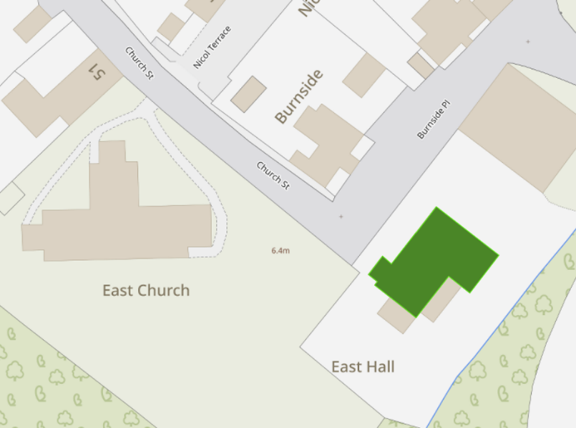
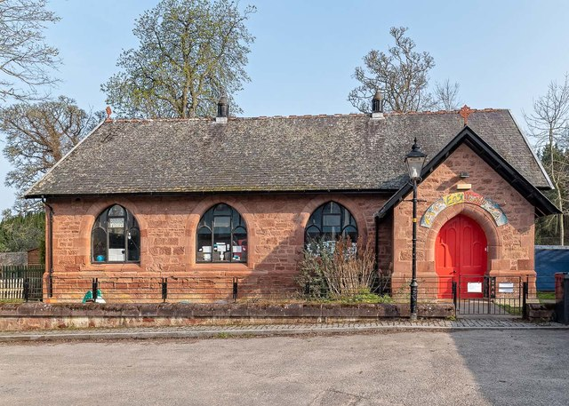

Representations
This consultation seeks the views of the Cromarty inhabitants to inform the Council’s decision in respect of the Proposal as described above to -
- Dispose (by lease) of common good Property with the intention of a future disposal (by sale) via a Community Asset Transfer process;
- Change the use of common good Property to an enterprising community hub.

This consultation is specifically in relation to the statutory requirements relating to common good. Should the Proposal proceed, further statutory consents will be required, including those related to Planning.

Key questions:
- What are your views on the Proposal utilising common good Property?
- Do you have any views on potential benefits of the Proposal?
- Do you have any issues or concerns arising from the Proposal?
- What are your views on a future disposal (by sale) of the Property via a Community Asset Transfer request?
- Do you have any additional comments?

The Council will take all representations received into account in reaching a decision. A report of the outcome of the consultation will be presented at the Black Isle and Easter Ross Area Committee and a copy of the representations and responses will be published on the Council’s website.

The possible outcomes are:
- The proposal goes ahead subject to consent by the Sheriff Court.
- The proposal is amended significantly, and a fresh consultation takes place.
- The proposal does not go ahead.

Please submit written representations either online, by email or post:
- Online - https://forms.office.com/e/eQW4GmYDZm
- Email: common.good@highland.gov.uk
- Post: Common Good Fund Officer, Highland Council, Headquarters, Glenurquhart Road, Inverness, IV3 5NX.

Timescales
The consultation period will be open for 8-weeks commencing from 4 August 2025.
Final written representations must be received by close of play 29 September 2025.

It is anticipated that a report will be presented at the Black Isle and Easter Ross Area Committee on 10 November 2025.

Additional Information
All Common Good property falls into one of two categories – alienable or inalienable. Alienable property can be sold, leased or have its use changed in a way that reduces public use (subject to statutory consultation). Inalienable property is also subject to statutory consultation with the additional requirement to gain court consent in terms of Section 75 Local Government (Scotland) Act 1973.

The subjects of this consultation, i.e. the Property, is owned by the Council in terms of the title deed: Trustees for the Congregation of Cromarty Parish Church in favour of the Provost, Magistrates & Councillors of the Burgh of Cromarty together with a Minute of Waiver by Colonel George Duncan Noel Ross (superior) both recorded 8 November 1962. The Minute of Waiver varied the restriction of religious or education use to provide that the hall should be used “in all time coming for social and community purposes in connection with the town of Cromarty”. In addition, “the owners and successors are specifically prohibited from using the said subjects for commercial or industrial purposes or for use as domestic living quarters”.
It is believed that the property may be inalienable common good. Therefore, if following the consultation, the Council wish to agree to the request they must apply to the Sheriff Court for consent. The court process will provide a further opportunity for the public to make representations on the proposal. A statutory advertisement will be placed in the local press to inform the public that a court process has commenced.

