
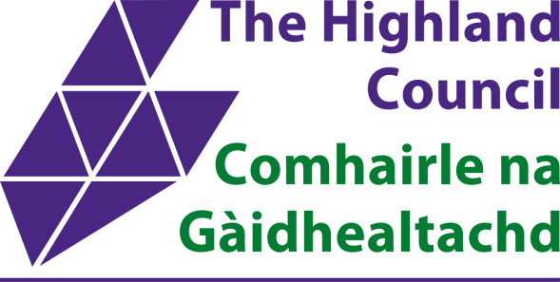

www.researchresource.co.uk/AJHighlandHNDA
.
l
htm
info@researchresource.co.uk
k
www.researchresource.co.u
We want to hear from you!
HIGHLAND HOUSING NEED &
DEMAND SURVEY
www.researchresource.co.uk/AJHighlandHNDA
.
htm
l
The Highland Council has
launched a survey about the
housing needs of local
households.
Whether you're a homeowner, tenant, or looking for a home in
Highland, take our quick 5
-
minute survey and help shape the
future of housing across the Highland region.
Have your say before the 7
th

November 2025
Take part in the survey by:
•
Completing an online survey via the survey link or by
scanning the QR code
•
Contacting Research Resource to complete a telephone
survey on 0141 641 6410 or at
info@researchresource.co.uk
The survey will be entirely confidential and will be treated in accordance with the Data
Protection Act. You can find out more about how Research Resource will treat the data
in their Privacy Notice on their website (
www.researchresource.co.u
k
).
The survey will allow the Council to plan for new
housing and housing services, making sure the
needs of all residents and communities are met.

