THE COMMUNITY EMPOWERMENT (SCOTLAND) ACT 2015
NOTICE OF CONSULTATION ON THE DISPOSAL, BY LEASE OF COMMON GOOD LAND.

Rosemarkie Caravan Park, Marine Terrace/Ness Road East IV10 8SE
The Highland Council (‘the Council’) has received a request to dispose, by lease common good land known to be the Rosemarkie Caravan Park (‘the Property’). Before reaching a decision, the Council must have regard to the views of Fortrose and Rosemarkie residents via a consultation in terms of Section 104 Community Empowerment (Scotland) Act 2015.

What is being proposed?
The proposal relates to a lease extension to the existing tenants of Rosemarkie Caravan Park site which is believed to be common good property (‘the Proposal’). In 2004 a lease was granted to the Caravan and Camping Club to operate the site however the lease is up for renewal and new provisional terms has been negotiated.

The Property covers a total area of 13,768.66 square metres, or thereby, occupying land at either side of Marine Terrace/Ness Road East located at the foreshore of Rosemarkie Bay. The area of the site is outlined in red on the plan below.

The current tenants have asked the Council to consider a lease extension for a period of 30 years which will give them the security to continue to operate the site and invest in new facilities. The Proposal would also provide the Fortrose and Rosemarkie Common Good Fund with security in knowing that the caravan park is being managed by tenants who has a strong track record.

For the duration of the lease, the Fortrose and Rosemarkie Common Good Fund would receive rental income representing market rates and achieving Best Value for the fund. Should the Proposal go ahead, the new lease term will commence at the end of the existing lease period from 2026 until 2056. The rent will be reviewed every 5-years and the tenants being responsible for maintenance and repair of the site.

What land is affected?
The common good Property (outlined in red below) is located along Marine Terrance/Ness Road East at the foreshore of Rosemarkie Bay, adjacent to the Fortrose Golf Club Car Park.
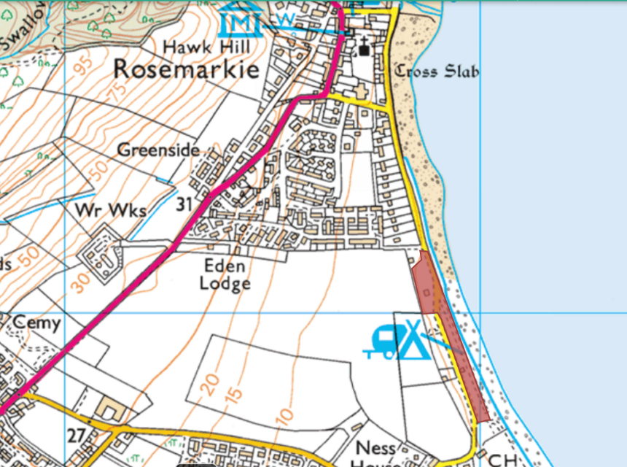

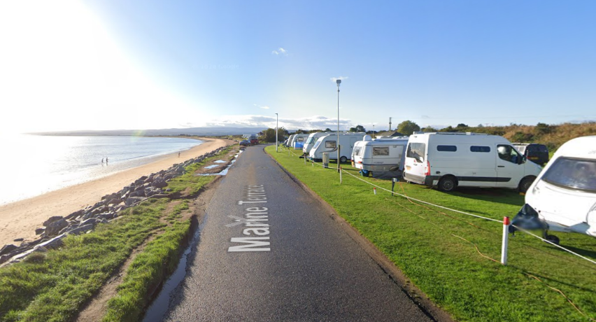

Representations
This consultation seeks the views of the Fortrose and Rosemarkie inhabitants to inform the Council’s decision in respect of the Proposal as described above to:
- Dispose, by lease common good land known to be the Rosemarkie Caravan Park site.

This consultation is specifically in relation to the statutory requirements relating to common good.

Key questions:

- What are your views on the Proposal utilising common good land?
- Do you have any views on potential benefits of the Proposal?
- Do you have any issues or concerns arising from the Proposal?
- Do you have any additional comments?

The Council will take all representations received into account in reaching a decision.
A report of the outcome of the consultation will be presented at the Black Isle and Easter Ross Area Committee and a copy of the representations and responses will be published on the Council’s website.

The possible outcomes are:
- The proposal goes ahead.
- The proposal is amended significantly, and a fresh consultation takes place.
- The proposal does not go ahead.

Please submit written representations:
- Online: https://forms.office.com/e/PjnNYu6MnR
- Email: common.good@highland.gov.uk
- Post: Common Good Fund Officer, Highland Council, Headquarters, Glenurquhart Road, Inverness, IV3 5NX.

Timescales

The consultation period will be open for 8-weeks commencing from 4 August 2025.
Final written representations must be received by close of play 29 September 2025.

It is anticipated that a report will be presented at the Black Isle and Easter Ross Area Committee on 10 November 2025.

Additional Information

All Common Good property falls into one of two categories – alienable or inalienable. Alienable property can be sold, leased or have its use changed in a way that reduces public use (subject to statutory consultation). Inalienable property is also subject to statutory consultation with the additional requirement to gain court consent in terms of Section 75 Local Government (Scotland) Act 1973 if a question arises whether the property can be alienated.

The subjects of this consultation i.e. the Property is owned by the Council in terms of the Charter for Fortrose by King James VI dated 6 August 1590 and the Charter for Fortrose and Rosemarkie by King James VI dated 4 November 1592 (both were ratified by King Charles II on 20 May 1661) and may be inalienable common good. However, the Council believes that following the statutory consultation, this Proposal does not require court consent. Circumstances have not changed, and the Property will continue to be used as it has for many years.

