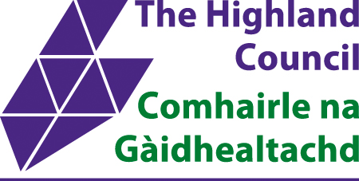

St Duthus School
HIGHLAND COUNCIL| Academy Street, Tain, IV191ED
STANDARDS AND QUALITY REPORT AITHISG INBHEAN IS CÀILEACHD

2024/25

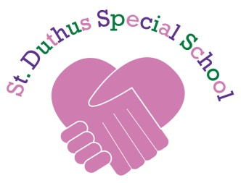

School Profile
Pròifil na Sgoile

It is important to remember that statistical data alone is not a measure of how well we are doing. All schools are unique. To understand how well we are doing it is important for us to look at a range of different sources.
St Duthus School is in a rural coastal setting serving a wide geographical area ranging from Alness in the South to Bonar Bridge in the Northwest, Golspie in the North and the Dornoch and Tain areas. We are a specialist provision for pupils aged 4 – 19 who have complex additional support needs.

There are currently 27 children attending the school. We have 5 composite classes in total: 1 x P1-P3, 2 x P4–S3 and 1 x Senior Phase Classes S4-S6.

Our purpose built, temporary school building opened in August 2015. We will be moving into the new Tain Community Campus in 2025/26.

Staff provide a supportive and nurturing environment for pupils and have developed good relationships with our partners, including the team of wider professionals and parents. We very much encourage a team approach to meeting the needs of our young people.

As the school roll comprises a small number of children, attainment and progress will be expressed in ‘overall’ statements, rather than specific year groups or Curriculum for Excellence levels. This is to ensure the identity of individuals is not disclosed.

We have had no exclusions this year.

Data relating to our context:
 |  | Pupil Numbers  27 |  | Attendance  88% |  |  |  |  | Teacher Numbers (FTE)  8
Age 0-8  22.2% |  |  | Age 9-12  11.2% |  | Age 13-15  40.7% |  | 16+  25.9%

SIMD Q1  10-20% | SIMD Q2  20-30% | SIMD Q2  50-60% | SIMD Q3  10-20% | SIMD Q5  0-10% | Unknown  0-10%

Overall ASN  100% | Free School Meal  100% | EAL  0% | Glossary:  FTE – Full Time Equivalent  SIMD – Scottish Index of Multiple Deprivation 1= % of pupils living in most deprived areas 5=least deprived areas  ASN – Additional Support Needs  EAL – percentage of learners for whom English is an Additional Language

Attainment
P1-S3 – Broad General Education

In a Special School most children in Broad General Education will be working between pre-early milestones and early level. A few may be working within first in some areas. Children are assessed and their progress is tracked. Interventions are put in place where we feel a child is not making progress as expected in relation to their potential. For some children their progress may be lateral due to their individual circumstances and pupils may also participate in awards programmes.
Almost all children and young people will use a range of communication systems to communicate with each other and adults. These include but not exclusively signing, symbols and assistive technologies.

S4-S6- Senior Phase
Most children and young people are working towards accreditation at level 1 and 2 in a range of curricular areas. A minority of learners may be working at level 3 in some areas.
This year children and young people have attained accreditation in the following areas.
Maths, English, Creative Arts, Social Subjects, Science, Physical Education, Food, Health and Wellbeing.

Destinations of School Leavers
All our school leavers are going on to positive destinations.

School vision, values and aims
Lèirsinn, luachan agus amasan na sgoile

RESPECT • ACHIEVEMENT • COMMUNITY • HAPPINESS • COMPASSION

Review of progress of improvement plan projects for session 2024/25
Ath-sgrùdadh air adhartas airson an t-seisein

These projects are linked to the priorities for Scottish Education based on the National Improvement Framework aimed to deliver excellence and equity. Parent/Carer information is available here.

School Improvement Plan Priority 1 Transition to new Campus.
Rationale:
It has been agreed that Tain Royal Academy, Craighill and Knockbreck Primary Schools and St Duthus School will relocate to a single campus on a site at Craighill in Tain. Change and the relocation to a new school can be very difficult for children and young people.
Summary of impact : | Next steps
- Priority still ongoing due to delays in construction progress  - Head teachers continuing to have regular update meetings  - Specialist equipment and IT requirements identified  - School name reviewed and new school badge design under consideration.  - Review of pupils needs in regard to new school environment  - New school layout and walkthrough shared with staff and pupils. | - Continue regular update meetings on progress  - Finalisation of new school badge  - Review school hours for moving into new campus.  - Organise removal of current resources and equipment.  - Create closer links with primaries and secondary school developing links to mainstream classes and specialist curriculum areas.  - Transition to new building with visits and activities to create familiarity and a positive experience.

School Improvement Plan Priority 2 Curriculum Rationale
Rationale:
St Duthus School has experienced significant changes in staff especially the Head Teacher, the school is also relocating. It would be beneficial for pupils, parents, staff and partners to review the curriculum rationale to have a shared understanding of what the St Duthus pupils need to learn.
Summary of impact | Next steps
- Working groups created with staff to review and evaluate aspects of the school and community.  - Community groups developed strong links and cooperation with local groups.  - Parents evaluations and views sought on the school and activities offered. Areas identified to develop further with desire for inclusive and life-skills based curriculum.  - Life skills built into the curriculum with focus on art, music, PE and work experience. | - Refresh working groups and continue and continue to retrieve and collate information and views.  - Seek further views of parents, staff and partners further to develop full picture of views and opinions of the whole school community.  - Develop curriculum further with an inclusive and life skills based approach.  - Develop a full understanding of what our learners needs, gathering pupil’s views utilising Wee HGIOUS.  - Complete and create St Duthus Curriculum rationale for 25-26.

School Improvement Plan Priority 3 Assessment, tracking and monitoring.
Rationale:
To raise attainment for all our children and young people within BGE and Senior Phase by improving our planning, assement and tracking. We will be able to identify the best approaches to improve outcomes for our learners and know if they are making progress by having systems in place that can track this.
Summary of impact | Next steps
- Improved understanding of planning and tracking and confidence in use via new tracking and monitoring system introduced.  - Standard format for BGE and senior phase introduced.  - IEP’s reviewed termly  - Moderation of assessments and pupils work developed understanding and confidence among staff and increased identification of interventions.  - Increased consistency of judgements among staff and increase of staff confidence. | - Continue to develop planning, assessment and tracking to reinforce and develop confidence.  - Continue to use a range of assessments to support learning with focus on identifying next steps.  - Develop links with specialist teachers further with view of increased cooperation post move to new campus.  - Review and moderate IEP’s.  - Increase accuracy of data allowing more individualisation and differentiation of work for pupils.  - Planning, Tracking and Data attainment meetings scheduled

Progress and impact of Pupil Equity Fund
Adhartas agus buaidh Maoin Cothromas Sgoilearan

Attention Autism is being used to deliver the curriculum and is very popular with teachers and students. Most pupils engage with Attention Autism. Teacher confidence is improving and developing and gaining experience in the use of attention autism will be continued.

Whole school approach to communication with home as well as evidencing work and IEP’s which was very well received by both parents/carers and staff. Increased engagement from home evident and continue to use this format and system for moving forward.

Digital software use and confidence in this to be developed further among both staff and pupils with tablets to develop access to learning activities to still be pursed to aid this action.

Wider achievements
Coileanaidhean nas fharsainge

Pupils have participated in the Dynamic Youth Award, Personal Development Award and the Bronze Wild Challenge Award. Pupils attend the Disability Sports events and Competed in the Disability Sports Athletics Championships having successful outcomes across several events.

Capacity for continuous improvement
Comas airson leasachadh leantainneach

Using indicators from ‘How Good is our School 4’ together with learner, parent, carer, partner and community feedback we believe we have made progress as follows:

 | 2024-2025
QI 1.3 Leadership of change | Satisfactory
QI 2.3 Learning, Teaching and Assessment | Good
QI 3.1 Ensuring Wellbeing, Equality and Inclusion | Good
QI 3.2 Raising attainment and Achievement | Satisfactory
Other QIs reviewed

Our overall evaluation of our capacity for continuous improvement is:
We are confident in our capacity for continous improvement.
We are making progress to improve in our own practice and deliver quality learning. Through self-evaluation and collegiate activities we are identifying areas to develop and interventions needed to make positive changes.

Key priorities for improvement planning
Prìomhachasan airson planadh airson leasachadh

Improvement Priority Title
- Transition to the New Campus

- Curriculum Rationale

- Assessment, Tracking and Monitoring

Planning ahead
A’ planadh air adhart

Full details of the school’s 2024/25 improvement priorities and actions are detailed on the school improvement plan, which can be accessed by contacting the school office

Appendix 1: Local and National Context
Ro-ràdh: Co-theacsa Ionadail agus Nàiseanta

This Standards and Quality Report is influenced by both Highland and national priorities. These can be summarised as follows:

Highland Priorities  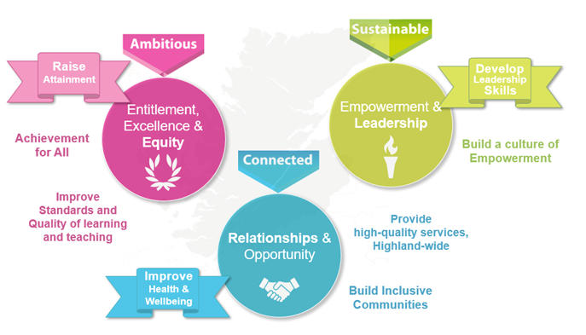  Accuracy?  Entitlement, Excellence & Equity:  We will raise attainment and achievement for all, especially for children and young people from disadvantaged circumstances, including rural deprivation. We will focus relentlessly on improving standards and the quality of learning and teaching, to ensure that entitlement, equity and excellence are delivered across the system.  Empowerment & Leadership:  We will develop leadership skills at all levels of the system, for now and the future, building a culture of empowerment and professional capital.  Relationships:  We will maximise health and wellbeing for all children and young people, to give them the best possible start in life. We will ensure every child and young person feels part of the community they live in.  Opportunity:  We will maximise opportunities for our children and young people, and for the wider Highland community and its visitors, through the provision of high-quality services. | National Improvement Framework Priorities  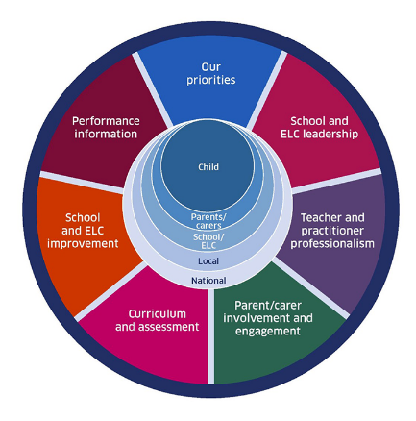  The key priorities outlined in the National Improvement Framework are:  - Placing the human rights and needs of every child and young person at the centre of education  - Improvement in children and young people's health and wellbeing  - Closing the attainment gap between the most and least disadvantaged children and young people  - Improvement in skills and sustained, positive school-leaver destinations for all young people  - Improvement in attainment, particularly in literacy and numeracy.  Self-evaluation  To support self-evaluation, quality indicators from the national evaluative framework How Good Is Our School?4 are referenced.  Links to these sources (and others referenced) can be found here:  National Improvement Framework Improvement Plan  HGIOS? 4 and HGIOELC  Health and Social Care Standards  National Gaelic Language Plan
In this report the following words are used to describe the numbers and proportions used:

All | Almost all | Most | Majority | Less than half | Few
100% | 91% - 99% | 76% - 90% | 51% - 75% | 16% - 50% | Up to 15%

This report forms part of our quality improvement framework and provides important information regarding our school’s progress to date and our next steps in school improvement.

Self-Evaluation for Self-Improvement is at the heart of our practice. We continue to develop our practice in making robust use of evidence as a basis for judgements regarding the impact of our work on our learners. All staff understand that self-evaluation is an integral aspect of our approach to continuous improvement through addressing the 3 key questions:

- How well are we doing?
- How do we know?
- What are we going to do now?

Throughout the year we continuously evaluate what we do and how it makes a difference to our learners. We want to know what is working well for our school community and what needs further improvement. We inform decision making and actions through a continuous process of looking inwards, outwards and forwards.

Looking inwards - starts with those working with our children and young people
We focus on the impact on outcomes for learners. Our self-evaluation processes triangulate information, data, people’s views and observation of practice to measure impact and inform planning for improvement.

Looking outwards - learning from others
Looking to others for new ideas that challenge our practice and support continuous improvement allows us to learn from what works and what doesn’t. This includes practice in other schools, learning communities and learning from educational research.

Looking forwards - creating a vision and planning for implementation
Through leadership at all levels, we anticipate challenges and explore creative solutions. This helps us to create an aspirational vision for our school which shapes our actions and provides a focus for improvement.
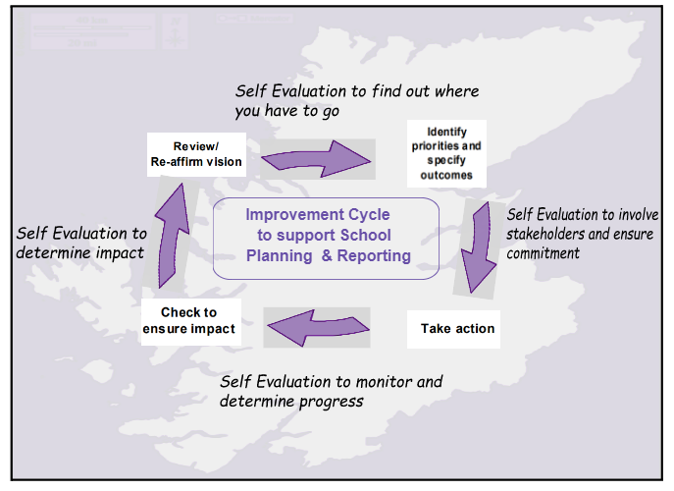
Our children and young people are actively consulted and involved in this process. We also give staff, parents/carers, and other partners the opportunity to participate in discussions and activities to shape our improvement journey.

When we develop our improvement plan, we use key questions at scheduled review times throughout the session to know how well we are progressing towards achieving these positive outcomes and changes.

Together we are working hard to ensure the Highlands is the best place for children and young people to grow up safely, learn, develop and achieve.

With positive experiences, our children and young people will always see the Highlands as home.
Le eòlasan deimhinneach, bidh ar cloinn is ar n-òigridh daonnan a’ faicinn na Gàidhealtachd mar dhachaigh.

Iain Maciver
Head Teacher
St Duthus School

Self-evaluation summary for school improvement - Core QIs – For professional dialogue – remove from parental versions
How well are you doing?  What’s working well for your learners? Not solely a description of what you have been doing…evaluative language (see guidance document p10-14) | How do you know? What evidence do you have of positive impact on learners? Observation/Peoples Views/Data  Impact – outcomes/practice/ systems and processes to inform these? | What are you going to do now?  What are your improvement priorities in this area? | How would you evaluate this QI using the HGIOS 4 six-point scale?
QI 1.3 Leadership of change
How well are you doing?  What’s working well for your learners? Not solely a description of what you have been doing…evaluative language (see guidance document p10-14) | How do you know? What evidence do you have of positive impact on learners? Observation/Peoples Views/Data  Impact – outcomes/practice/ systems and processes to inform these? | What are you going to do now?  What are your improvement priorities in this area? | How would you evaluate this QI using the HGIOS 4 six-point scale?
Encouraging all staff in taking forward leadership roles. | All staff have an leadership roles that directly relate to the improvement plan. Staff feel valued and there is a shared input to the school. | Regular meetings included with the WTA. Working groups to continue as part of our SIP. | Satisfactory
Working together with local secondary schools to develop links between teachers to provide YP with access to a wider range of curricular areas and increase attainment in more qualifications. | Teachers have subject links with TRA & any other Secondary Schools.  YP have increased curriculum offer.  YP working towards a wider range of awards and qualifications. | Look at transition into the new campus and maintain relationships with the Secondary schools.  Encourage staff engagement with Awards programme and continue to promote learner achievement across a wide range of subjects. | Satisfactory
QI 2.3 Learning, teaching and assessment
How well are you doing?  What’s working well for your learners? Not solely a description of what you have been doing…evaluative language (see guidance document p10-14) | How do you know? What evidence do you have of positive impact on learners? Observation/Peoples Views/Data  Impact – outcomes/practice/ systems and processes to inform these? | What are you going to do now?  What are your improvement priorities in this area? | How would you evaluate this QI using the HGIOS 4 six-point scale?
Developing Vision and Values  Driving forward improvements in Teaching & Learning leading to continued improvements in progress and achievement.  Teachers planning lessons to ensure they engage the interest of all learners and take account of individual need.  Continuing to use a wide range of assessments to gather more evidence to show accurately how well learners are progressing.  Teachers use assessment information to plan lessons which build more appropriately on prior skills.  Teachers use assessment to plan lessons ensuring appropriate level of challenge. | Staff are modelling the values in their daily practice.  Learning walks/ observations – individual action plans  Moderation CAT sessions  Joint Moderation with the Special School ASG | Collaboration between staff has improved. We will continue to moderate and improve our practice through professional learning and training. Staff will continue to be well supported to self-evaluate and re visit areas of improvement.  The school improvement plan will reflect this and methods to improve pupil & parent voices will be implemented. | Good
QI 3.1 Ensuring wellbeing, equality and inclusion |  |  | Good
How well are you doing?  What’s working well for your learners? Not solely a description of what you have been doing…evaluative language (see guidance document p10-14) | How do you know? What evidence do you have of positive impact on learners? Observation/Peoples Views/Data  Impact – outcomes/practice/ systems and processes to inform these? | What are you going to do now?  What are your improvement priorities in this area? | Good
All staff complete annual CP training & FGM training.  Ensure there is a consistent understanding of the uniqueness of St Duthus.  Parents, learners and partners involved in the work of the school.  Ensure that all parents have opportunities to be fully involved in or at least aware of the school improvement priorities.  Staff developed approaches to communication that parents find more easily accessible.  Create for parents and learners. Signpost to agencies and activities that learners can access when not in school. | Training register  Wellness Wednesday  Sessions for parents within the classes. To the partnership event. New campus session.  Parents invited to join SIP discussion.  Successful transition event. | Further develop links with partners for parents and pupils.  Provide parents/carers with opportunities to develop knowledge learn about new digital technology and platforms that we will be using. | Good
QI 3.2 Raising attainment and achievement |  |  | Satisfactory
How well are you doing?  What’s working well for your learners? Not solely a description of what you have been doing…evaluative language (see guidance document p10-14) | How do you know? What evidence do you have of positive impact on learners? Observation/Peoples Views/Data  Impact – outcomes/practice/ systems and processes to inform these? | What are you going to do now?  What are your improvement priorities in this area? | Satisfactory
Staff have developed how the school celebrates and recognises learners’ achievements through class awards, assemblies, participation in our Values board, accessing SQA and award programmes.  As a school we are working more effectively with partners to support learners to develop their achievements in their local community. | End of year celebration service  Assemblies  Wellness Wednesday – activities to support pupil wellness.  RNLI Lifeboat celebration  St Duthus Run at the GALA  Participation in St Duthac Art & Book week. | Continue with Awards programmes and celebration as a school through assemblies. Parents and pupils enjoyed the School awards so this will continue.  Work with the For you & Farmer Jones project to develop skills and employability options.  Staff engaging with work force & strategic groups to develop partnerships and transitions. | Satisfactory

