For Official Use: Cash Office/Service Point

Financial Code: 10-0-1041009-00000-42096

APPLICATION FEE: | £126 |  | 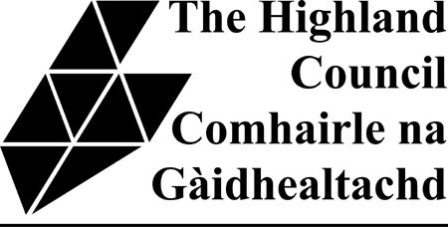
FEE PAID:
RECEIPT NO:
DATE RECEIVED:
RECEIVED BY:
(SERVICE POINT & INITIALS)

THE LICENSING (SCOTLAND) ACT 2005
HIGHLAND LICENSING BOARD

Application for Food Hygiene Certificate under Section 50
of the Licensing (Scotland) Act 2005

Application is hereby made by

……………………………………………………………………………………………………………………………

……………………………………………………………………………………………………………………………

To THE HIGHLAND COUNCIL as Food Authority in terms of S. 16 of the Food Safety Act 1990 (c. 16)
for the following certificate as to suitability of the premises at

…………………………………………………………………………………………………………………………..

…………………………………………………………………………………………………………………………..

for a premises licence under S.20 or confirmation of a provisional premises licence under S.46 for which a S.50 Certificate is being sought, in relation to food hygiene.

Data Protection – the information you have supplied will be used for the purpose for which you have provided it and any relevant procedures following from this. This data will be maintained in accordance with the Data Protection Act 1998 and will not be passed on or sold to any other organisation without your prior approval unless this is a legal requirement.

Date .............................................. Signature ..................................................………………..
(Applicant/Agent)

Address of Agent (if any) …………...………………………..

………………………………………………………………….

………………………………………………………………….

Daytime tel no: ……………………………………………………....................................

Fax no: ……………………………………………………………….......................

Mobile no: ……………………………………………..................................................

E.Mail: ………………………………………………….…………………………….

The completed application form should be sent to the appropriate Area Environmental Health Office or emailed to : envhealth@highland.gov.uk

These are:

- Caithness, Sutherland
Senior Environmental Health Officer
Caithness House, Market Place, Wick, Caithness, KW1 4AB

- Ross, Skye & Lochaber
Senior Environmental Health Officer
Ross House or Charles Kennedy Building or Broom Place
71 High Street Achintore Road PORTREE
DINGWALL FORT WILLIAM IV51 9HL
IV15 9QN PH33 6RQ

- Inverness, Nairn, Badenoch & Strathspey
Senior Environmental Health Officer
Council Offices, 38 Harbour Road, Inverness. IV1 1UF.

WAYS TO PAY:
By Debit or Credit Card
- In Person at any Service Point
- By Telephone to a member of Council staff. Please telephone the payment line on 01349 886605/09 and a member of staff will be able to take your payment. This service is available Monday-Friday 8 am to 5 pm,

By Bank Credit Transfer, Telephone or Online Banking or Standing Order
Please pay to the: Virgin Bank, 15 Academy Street, Inverness, IV1 1JN
Bank Sort Code: 82:70:13
Bank Account Number: 30000542
Please quote: Name of Premises/Type of Application or Invoice Number with all payments.

