Fort Augustus & Glenmoriston Community Company
Redevelopment of Novar, Station Road, Fort Augustus
(aka Janitor’s House)
Business Plan
31st October 2024

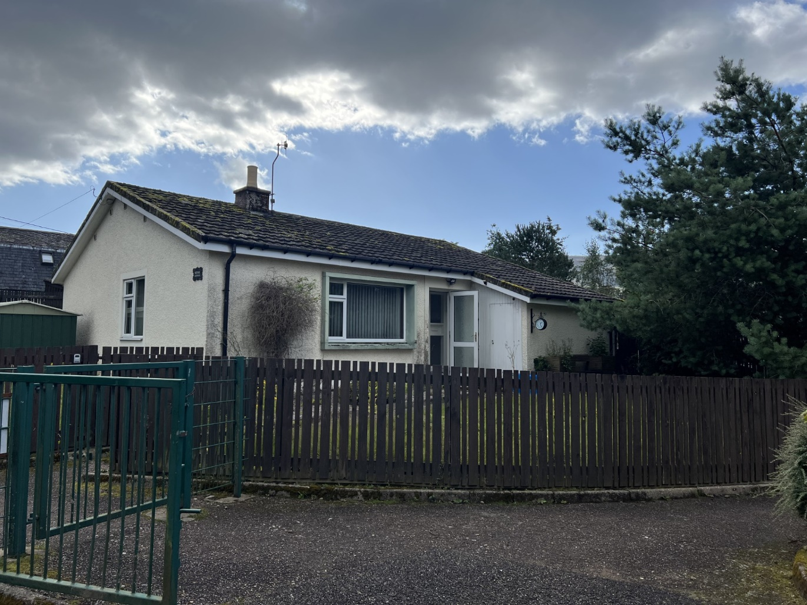

Contents
Executive Summary 3
Background 4
Timeline of achievements 4
Community vision 5
Governance 6
Board 6
Staff 6
Partnerships 6
Community-led housing 7
Housing need 7
Affordable housing 8
Affordable Housing Policy 8
Housing Allocations Policy 9
Novar, Station Road Revenue costs 12
SWOT 13

Executive Summary
Fort Augustus & Glenmoriston Community Company (FAGCC) will purchase Novar aka Janitor’s House and upgrade it to a home suitable for affordable rent. There is evidenced demand for 3 bedroom homes in the area as evidenced in the Housing Needs Survey, the Highland Housing Register and recent applications to FAGCC for housing.
Funding for the purchase price of £70,000 will be sought from Community Benefit Funds.
The Development costs of £145,200 will be funded through the Scottish Government Rural &Islands Housing Fund, Fern Community benefit funds and other suitable funding streams available to it.
The homes will be rented out at affordable rents equivalent to Highland Council levels for similar properties. After costs and a contribution to the housing maintenance fund there will be a surplus of £1,002 per annum.

Background
The Fort Augustus & Glenmoriston Community Company (FAGCC) was established by the Community Council in 2007 as the approved body to receive & distribute community benefit to the Fort Augustus & Glenmoriston area. FAGCC is a company limited by guarantee and a registered charity. Ordinary Membership of the company is drawn from the Fort Augustus and Glenmoriston Community Council area. The majority of the board of directors are democratically elected by the membership from the membership up to a maximum of nine. The community council can appoint one of their members onto the FAGCC board. The board also have the option to co-opt up to three directors.
In addition to distributing community benefit funds to local groups, FAGCC aims to promote rural regeneration in areas of social and economic deprivation within the community. To that end FAGCC undertakes key projects which contribute to priority needs of the company as set down in the community action plan.
Community benefit income received annually is typically around £600K. Whilst FAGCC receives this income there are restrictions on how that money can be used, it is not unrestricted. Of this figure approx. £153k is allocated to the community caretakers scheme, £190k for the office including staffing, 25k for the apprenticeships and 220k for grants to local community organisations. In addition monies are set aside for designated community benefit projects that the Company has committed to and a reserve fund, for use once community benefit monies are no longer received. FAGCC applies for match funding when carrying out developments and to date FAGCC has taken around £2.9 million of match from varying sources.

Timeline of achievements
FAGCC has made significant achievements since its inception, what follows is a brief timeline overview of those achievements
2007 - FAGCC established to receive and distribute windfarm money
2009 - FAGCC establishes the grant programme. FAGCC runs a successful multi strand grant programme offering grants to groups, individuals for community benefit and students/apprentices. FAGCC supports a wide diversity of projects, all of which benefit or further the development of the local community.
2010 - FAGCC takes ownership of the Fort Augustus Village Hall, builds an extension and instals solar panels. FAGCC continue to support the hall through an annual grant as well as managing it on a day to day basis.
2013 - FAGCC launches an apprenticeship scheme. The apprenticeship scheme is run jointly with Stratherrick and Foyers Community Trust and the Glengarry Trust. The scheme offers young people the opportunity to live, work and train in their local communities. To date the Community Company has supported 10 young people from the Fort Augustus and Glenmoriston area complete their apprenticeships.
2014 - FAGCC establishes the Community Caretaking team. The Community Caretaker team undertakes grass cutting, litter and leaf clearance, gritting and care for the cemeteries in Fort Augustus.
2016 - FAGCC Secures funding and takes ownership of the burnt-out medical centre and grounds with a view to building a new one.
2017 - FAGCC secures funding and takes ownership of No. 2 Bunoich Crescent. Access to affordable housing is a major issue and this is FAGCCs first foray into community housing.
2018 - FAGCC facilitates the completion of a Community Action Plan (CAP) for the area. The CAP identifies priorities for action including the provision of affordable housing.
2018 - FAGCC Secures funding to purchase the 17 acres of the Old Convent Land. An investment for the future, the purchase gave the community control over the land and how it could be used.
2019 - FAGCC completes the build of the new Cill Chuimein Medical Centre. The medical centre is leased to the NHS. Double the size of the old one, the aim is that it becomes a one stop shop for all things health related.
2019 - FAGCC begins plans for building 12 new homes for affordable rent on a section of the convent land.
2020 - FAGCC secures funding, awards the build contract and work begins on building 12 new homes on the Old Convent Land.
2021 - FAGCC completes work on the 12 new homes at the newly named Caledonian Court and by Autumn of 2021 the homes are fully tenanted.
2022 - FAGCC secures funding to purchase another property for affordable rent, No.1 Bunoich Crescent. The property is refurbished and tenanted in April 2022.
2022 - FAGCC completes a review of the Community Action Plan to ascertain if priorities have changed post COVID. The community priorities remain the same.
2023 – FAGCC purchases the local hardware store to retain the amenity for the community and to introduce new product lines to service local need such as basic fresh food supplies.
2023 – FAGCC purchases 6, Riverside Park in Invermoriston. The property is insulated and refurbished with new tenants in December 2023.

Community vision
Work on the Community Action Plan revealed the community vision for the Fort Augustus and Glenmoriston area.
Great community and recreational facilities and opportunities.
- Local access to high quality indoor and outdoor recreational facilities.
- Places where the community can come together for socialising, activities and events.
Sustainable population – housing and services
- Good mix of all ages with a growth in population to maintain local services
- Education, health and care services at the heart of the community
- More housing for the needs of the community and economy
Diverse economy and job opportunities
- A wider range of businesses, training and job opportunities
An attractive place to visit and stay and enjoy the wider area and outdoors
- A great tourist destination that has made the most of its natural and cultural heritage and its strategic location at the heart of the Great Glen.
A well connected community
- Better transport, better roads, faster broadband and better mobile reception

A green community
- More recycling
- Better access to renewable energy for households, businesses and community buildings
- Support for local food production

Governance

Board
FAGCC currently has ten Directors nine of whom are elected from the community, one appointed by the community council. FAGCC has the option to co-opt a further three directors onto the board for a one year term. At the time of writing this plan there is one co-opted Director. The board meets monthly at alternating venues between Dalchreichart, Invermoriston and Fort Augustus. Grant applications are discussed at the next available board meeting and management accounts are reported quarterly following the quarterly Finance & Resources sub group meeting.

Staff
FAGCC employs 5 office staff, an equivalent of 3 FTE.
The Operations Manager heads up the team with over 5 years’ experience of working in this community and a further 35 years in Operational Management roles in both corporate and charitable organisations.
She is supported by an Operations Supervisor and Facilities Manager both bringing a wealth of experience in working with communities in different capacities.
FAGCC also employs an experienced Finance Manager and Book Keeper ensuring that the accounts are up to date and accurately recorded. This also enables the Operations and Facilities Manager to have to up to date financial information to closely monitor budgets and forecasts throughout the year reporting to the Finance and Resources sub committee on a quarterly basis.
FAGCC employs six Community Caretakers who take care of the areas environs and carry out small development projects.

Partnerships
FAGCC works closely with other community groups operating in the Fort Augustus & Glenmoriston area in particular with asset owners, West Glenmoriston Community Hub and Glenmoriston Millennium Hall Community Association.
FAGCC supports 3Glens Community Care and is a partner in the 3 Glens Resilience Group that includes Glengarry, Glenmoriston and Fort Augustus. FAGCC continues to work with these partners.
FAGCC has close links with the neighbouring community organisations of Stratherrick and Foyers Community Trust, Laggan Community Council and the Glengarry Trust. We work together on the Apprentice programme and ensure that other work we do complements and adds value where appropriate.

Community-led housing
Community-led housing has many benefits including:
- ​Provides an additional supply of affordable homes;
- Generates community support for new homes;
- Helps diversify the house building types and tenure options in communities;
- Assists the local economy and trades provision;
- Builds capacity within community groups and sets a positive example to others;
- Helps to attract financial investment to communities;
- Improves spaces and the built environment;
- Provides choice for older people needing age appropriate housing;
- Gives younger people an opportunity to realise their housing ambitions;
- Supports sustainable and economically vibrant communities;
- Helps people afford to rent, buy or build their own homes;
- Supports an innovative approach to partnership working and to providing solutions;
- Supports social and economic growth in the community.

Housing need
Identifying Housing need
The 'needs gap' for affordable rented homes is clearly set down in the housing needs survey undertaken by Rural Housing Scotland in November 2018. A new survey is currently being undertaken but the Highland Housing register indicates that little is likely to have changed. This established a clear need for properties and outlined how housing issues impacted on both individuals, employers and the community. On the face of it, Fort Augustus appears relatively affluent and this is borne out by its position on the SIMD list. However, poverty is often hidden. For much of the year, there is little unemployment and salaries appear reasonable but many jobs are tourism related and seasonal so the income for 8 or 9 has to last for 12 months.

The Highland Housing Register (HHR) demand and supply tool provides a guide to the likelihood of an applicant securing a house in a particular area by setting out the number of people on the register looking for each size of property, the number of social rented houses of each size in the area and the number of times each size of property has been let in the last financial year. In addition to the HHR data we have included our own housing stock data and the demand identified during the Housing Needs Survey in 2018 in the table below.
Highland Housing Register |  |  |  | FAGCC
Size | Number registered | HHR Stock | Lets 04/23 - 03/24 | Housing needs survey 2018 | FAGCC stock | Lets 04/23 - 03/24
1 Bed | 83 | 17 | 1 | 6 | 0 | 0
2 bed | 23 | 32 | 5 | 11 | 10 | 10
3 bed | 20 | 25 | 1 | 3 | 5 | 5
4 bed | 6 | 3 | 0 | 1 | 0 | 0
There is very little turnover in the HHR stock and the FAGCC stock is fully occupied. You can see from the table above that demand is very high and far outstripping supply.
The table below indicates the recent level of interest FAGCC has in their properties and the type of households seeking affordable accommodation. This backs up the HHR and Housing Needs Survey, with the single and couple category, ie requiring 1 or 2 bedrooms, being the most in demand.
Last let | Property | interest | single | couple | family | single parent | unknown
2020 | 2 Bunoich Crescent | 9 | 0 | 4 | 0 | 2 | 3
2021 | 1 -12 Caledonian Court | 62 | 19 | 15 | 10 | 14 | 4
2022 | 1 Bunoich Crescent | 14 | 2 | 5 | 4 | 3 | 0
2023 | 6 Riverside Park, Invermoriston | 2 | 0 | 1 | 1 | 0 | 0
2024 | 5 Caledonian Court, 2 bed bungalow | 18 | 7 | 7 | 3 | 1 | 0

Affordable housing
The economy of the area is dominated by tourism which leads to seasonal work patterns and a shortage of rental accommodation when holiday rentals are more lucrative. Bed spaces in the key tourist season are at a premium and this in turn pushes up the cost of the few rental properties - £600 to £800 for a room is not uncommon and is not affordable; private rentals are typically 1 1/2 times higher than in nearby towns. What private rented accommodation there is, is often expensive, inappropriate for needs and often in poor condition.
The Community Action Plan highlighted second homes and the cost of housing in the area. At the time of the CAP there were ~678 houses in the area of which ~503 are occupied, ~24 are empty and ~151 are second homes. The most recent report from the Empty Homes Officer indicates that there are now 70 empty homes. Overall there is a higher percentage of houses occupied by one person households aged 65+ and two people households over 75 years old than is the case for Highland and Scotland.
FAGCC owns fifteen homes for affordable rent. Twelve of those homes are new builds completed in 2021 and the other three were purchased separately and refurbished. This complements our apprenticeship scheme which works with young people under 25, to allow them to secure qualifications and long term employment. To enable them to stay in the community they need a long term home where they can put down roots, start relationships, maybe start a family. Whilst anyone who meets our criteria will be able to apply for a property, apprentices are allocated additional points in the process. Affordable housing is transformational for the local community, in particular for young people.

Affordable Housing Policy
FAGCC is a private landlord and offers properties to rent on a private rented tenancy at an affordable rent.
We recognise that access to affordable housing is key to developing a sustainable community and ensuring the regeneration of our rural communities. We aim to offer all our properties for rent on an affordable basis.
Note that we define ‘Affordable’ as leasing properties at a rent that is compatible with the Highland Council or the local housing association. Our policy is to ensure that rental levels charged do not exceed 100% of the Local Housing Allowance. We do not define mid-market rent as affordable.
Policy Statement
We wish to support individuals and families who live in, or wish to return to, the Fort Augustus and Glenmoriston Community Council area and are unable to afford to buy their own home or are struggling to find affordable accommodation to rent. We also want to support people who are looking to establish their first home.
We want people who rent our properties to feel that the property is their home for as long as they want to live there.
We recognise the close connections that exist with surrounding communities, in particular Invergarry, and applications will be considered from this area.
Policy Aims
By providing access to affordable housing for the communities of Fort Augustus and Glenmoriston Community Council area we will:
- Support individuals and families who have strong local connections and are looking to return to their home community, including returning members of the armed forces (notice must have been handed in).
- Support local young people, including single people, into their own homes and encourage them to stay in, and contribute to, their community, especially where they have gone through an apprenticeship programme.
- Contribute to the sustainability of our communities by providing quality, suitable accommodation, rented at an affordable level, which is cost effective to run.
- Improve the living conditions for local people who are in poor quality rented stock (including under and over occupied properties).
- Support key workers who are unable to secure a property and are essential to the local community and the economy.
To put this policy into practice, we will:
- Operate a clear and transparent allocations procedure and points system that meets the aims of the policy, for all properties within the ownership of FAGCC in a manner that does not discriminate or exclude people
- Look to develop further housing where the opportunity arises, either new build or purchase, if the need is there.
- Work with our tenants to ensure they feel secure and are able to make a long term home for themselves and their family and to contribute to the local community.
- Ensure rental levels remain affordable as outlined in the context statement at the start of this policy.

Housing Allocations Policy
Our allocations policy will aim to make the best use of the housing stock, within the ownership of FAGCC, by allocating it to household/individuals who best meet the aims of our affordable housing policy.
All applications will be treated in confidence and all applicants will be treated equally in line with our equalities policy.
Allocation Procedure
- FAGCC will maintain a waiting list of anyone who is interested in renting one of our properties..
- The applicant should contact the FAGCC office if they want help in completing the form.
- If the applicant no longer wants to stay on the waiting list, they should inform the FAGCC office.
- Members of the housing subgroup will be informed of the names of any applicants and if there is a direct relationship with any applicant they will declare it and therefore will not take part in the assessment of their application form and allocation of points if a direct conflict exists.
- Should any director of FAGCC wish to be on the housing waiting list, they will not sit on the housing sub group and will not take part in assessments as long as they remain on the waiting list.
- Applications will be reviewed and applicants may be contacted to clarify details of their application to ensure all applications are treated fairly.
- All applications will be assessed ‘blind’ with the applicants names removed. There will be a minimum of 3 directors to review any application. If only 2 directors are available an independent third party will be brought in to oversee an allocation.
- Points will be allocated to the 1 person in the household who scores the highest. This is to ensure a single person has an equal chance of securing a property.
- The number of points will determine a households place on the housing list, but allocation of a property is subject to being able to be matched with a property that meets their needs.
- When a property becomes available, those on the waiting list will be notifie, Facebook posts will be done on community pages and posters put up around the villages.
- We may ask to meet applicants either in their own home or at the office to discuss their application if further information is required.
- Successful candidate(s) will be contacted by phone and provisionally offered a property subject to successful references being received. 2 references will be requested; where the applicant is already renting we will need a reference from their current/most recent landlord and their current/most recent employer. We may also ask for bank statement, proof of identity and proof of address (utility bill/driving license or bank statement).We will undertake any other checks we deem necessary.
- The candidates will be informed if references are successful by phone and will then have 5 working days to accept or reject the offer. Once accepted, tenancy paperwork will be issued in due course.
- If the candidate rejects the property, it will be offered to the next suitable household on the list.
- The successful candidate should be aware that their name will be made public unless there are exceptional circumstances.
- If an applicant feels they have not been treated fairly they should approach the Operations Manager to explain why. The Operations Manager will inform the board. If appropriate, their application will be reviewed by an independent third party in line with the FAGCC complaints policy.
- Candidates may see their own total points but not that of any other applicant.

Applicants should be aware of the following:
- Tenants must occupy the house as the household’s sole home. It may not be let as rental or holiday accommodation. Lodgers may be considered but only with the prior written permission of FAGCC.
- A deposit equivalent to one month’s rent is required which will be lodged with Safe Deposit Scotland.
- FAGCC is not a social housing provider so our allocation process operates differently to the Highland Council or Housing Association, as we have different aims.
- The tenancy that successful candidates enter into is a Private Residential Tenancy (PRT). The PRT is open ended and will allow you to stay in the property until you wish to leave, so as long as you do not break the conditions set down in the tenancy. A copy of the guidelines will be issued to every tenant along with the tenancy agreement. A copy can be made available to applicants before applying.
- We ask that all prospective tenants ensure they are registered with the Highland Housing Register. This will help establish local need and support more homes being built.
- If the tenant is on Universal Credit, rental money must be paid directly to us as landlord.
- Rent can be paid monthly, weekly or fortnightly by standing order or BACs payment
- A maximum of 2 pets will be considered, depending on type and breed and subject to additional clauses in the lease. Animals defined as dangerous will not be allowed, neither will breeding for profit. Please let us know what and how many pets you have.
- If you have debt issues, this will not stop you being considered but we will need to discuss with you your ability to pay.
- We will withdraw applications under the following circumstances:
- At the applicants request.
- If the applicant does not respond to a request for information within the specified timeframe.
- If false or misleading information is given.
- Where an applicant does not respond to a reminder letter.
- In the event of being unable to provide appropriate references.
- Whilst FAGCC will aim to treat every application on its own merits, it reserves the right to refuse to offer a property to a household where it may have a negative impact on our tenants. FAGCC considers that it has a duty of care to ALL tenants and will, in exceptional circumstances, take into account any activity undertaken by a prospective tenant.

Novar, Station Road, Fort Augustus (aka Janitor’s House)
Novar is a detached unoccupied three bedroom bungalow, previously used as the school janitor’s home. It has lain empty for 3 years as the Highland Council no longer offers the property as part of the package for the Janitor position.
FAGCC will upgrade the property. Development works will be carried out to a very high standard in terms of energy efficiency and sustainability resulting in a warm, economical and affordable home.
The addition of this affordable home to FAGCCs portfolio of affordable rented accommodation will be beneficial long term as the income from the rents grow. This income is ringfenced for community housing not just for maintenance of existing stock but also the purchase or build of new stock all of which will be affordable rented accommodation.

Capital cost of purchase and development
COSTS | Amount
Purchase price | £70,000
Development | £100,000
Professional fees | £20,000
Planning | £1,000
VAT | £24,200
TOTAL COST | £215,200
FINANCE
Community Benefit Fund - purchase | £70,000
SG Rural Housing Fund | £125,000
FAGCC development | £20,200
TOTAL FINANCE | £215,200

Revenue costs
Rents will be affordable and based on the Highland Council rental levels for similar properties. Expenditure costs are based on current costs for managing the other 15 FAGCC affordable homes.
The maintenance fund will be built up to ensure adequate funds for future requirements.
INCOME | Month | Year
Rent - | £467.00 | £5,604
TOTAL ANNUAL INCOME |  | £5,604.00
EXPENDITURE
Insurance |  | £700.00
Administration |  | £200.00
Servicing |  | £400.00
Repairs |  | £500.00
Maintenance fund @ 50% |  | £2,802.00
TOTAL ANNUAL EXPENDITURE |  | £4,602.00
ANNUAL SURPLUS |  | £1,002.00

SWOT
STRENGTHS  - High level of need and demand for affordable housing  - Track record of delivering successful housing developments  - Track record of successful RHF funding applications  - Experience managing 15 affordable homes and tenants | WEAKNESSES  - FAGCC doesn’t own property yet.  - Development costs are high to make this an affordable home closer to net Zero.
OPPORTUNITIES  - Rural Housing Fund open until March 2026  - Significant Community benefit funds to call upon  - Other grant funds may also be available | THREATS  - Demand for affordable housing drops  - Alternative affordable housing providers create new homes in the area  - Decision on sale of Janitor’s House takes too long  - Build costs increase due to inflation and other factors

