Common Good Consultation – additional information

Ground mounted solar PV array proposals at Blairliath Grazings 13-acre site (Tain North) and Blairliath Grazings 4-acre site (Tain South).

- What is the purpose of this consultation?
As both sites are held on the Tain Common Good Asset Register, the Community Empowerment (Scotland) Act 2015 stipulates that a local authority must conduct a consultation process before deciding whether or not to dispose and/or change the use of common good property. This ensures that the Council acts in a transparent way and allow communities to be involved in the decision-making process.

- What is proposed to be built and what will they look like?
The proposal is to build ground mounted solar PV arrays on both sites to generated renewable energy. The panels will have the same appearance as the common roof mounted panels which are numerous across the world. They will be mounted on metal framing just above ground level, and the panels will be inclined at a 30 degree slope, which results in a maximum height of 3metres above ground level. A small single external BESS is also being considered to assist with electricity peak demand and periods of little generation.

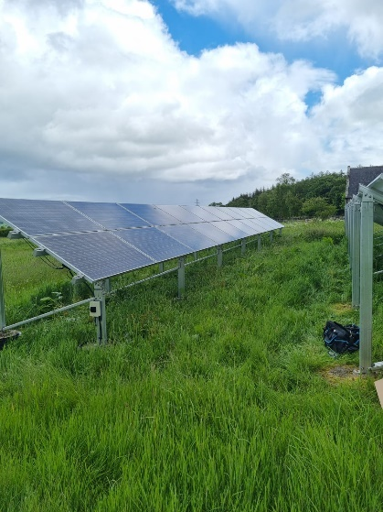 | 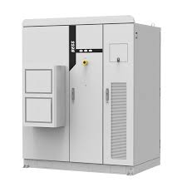 | 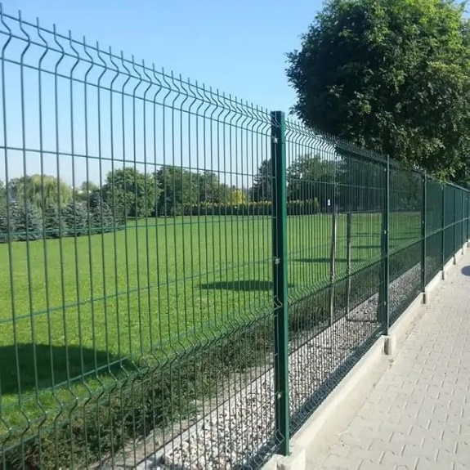
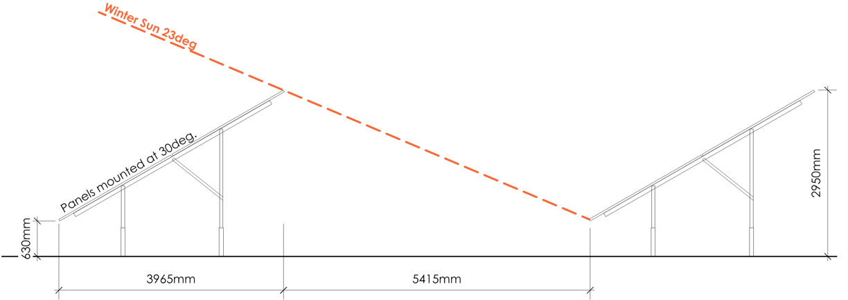

- Will the public be able to access the sites?
No, the sites would be fenced to discourage public access, using standard metal security fencing (see picture above) and CCTV will be installed to allow remote monitoring of the site and for security and health and safety reasons.

- Why these two sites?
Both sites are Council owned properties, held on the Tain Common Good Register, and following a review, it was determined that the sites had potential to generate renewable energy and thus additional revenue for the Council and Tain Common Good Fund.

In addition, commercial industry (off-takers) has been identified to use the electricity generated and both have confirmed their willingness to progress. Both projects will however only be delivered if a commercial business case offering a financial reward for the investment required is achieved.

- Why is a Battery Energy Storage System (BESS) included?
To increase the efficiency of the solar array and thus the financial return, consideration is being given to the inclusion of a small BESS to deal with the peak time of demand. It is envisaged that only one small external battery container on each site would be required for this demand. It would be ensured that this BESS meets all requirements in terms of health and safety.

- What stage are the projects at, and when are they expected to start generating electricity?
Currently only initial site feasibility work has been undertaken, including energy modelling, draft site layouts and early discussion with potential commercial off-takers for the energy generated.

Following the Common Good Consultation, the next stage would be to seek Planning Approval, which is proposed to take place in the Spring of 2026. Assuming that is approved, construction would take place in late 2026/early 2027 and electricity generation would start in mid-2027.

- How many panels on each site?
Tain North will have approximately 220 solar panels installed on a ground mounted steel framing system. Work is ongoing to identify the number of panels to be installed on Tain South site based on the energy demand required by the off-taker.

- How will the site be managed/maintained?
Following construction, on a day-to-day basis there will be little requirement for on-site presence. CCTV cameras will be installed across the sites to allow remote monitoring, and the panels operation and output will also be remotely monitored, with staff only attending if there are issues on site. Over the summer months limited ground maintenance such as grass cutting would be undertaken between the panels to ensure their continual efficient operation.

- Health and Safety Considerations?
The panels themselves have little to no health and safety risk during their life of operation. They will be appropriately recycled and disposed of at their end of life.

The installation of a small Battery Energy Storage System (BESS) is being considered to ensure increased efficiency and returns are achieved. Whilst any BESS installed will be more akin to a domestic battery system rather than a large BESS system, the project will ensure an exemplar health and safety approach will be advanced to reduce risks.

- Is the generated electricity going into the national grid?
No, due to capacity issues at both the Tain electricity sub-station and wider electricity network constraints there is no capacity to connect the proposed renewable electricity to the national grid. Instead, the generated electricity is proposed to be sold directly to the neighbouring business adjacent to each site.

- Has Planning Permission been granted?
No, planning permission has not yet been submitted and would only be progressed for each site once the outcome of the Common Good consultation is determined.

During the planning application, the standard planning public consultation process will be undertaken, and members of the public can comment and submit representations in relation to the detailed plans and technical aspects of the proposals. These will be considered as part of the planning determination which is a separate process to the common good consultation.

In 2019, both sites were granted planning permission for the installation of a solar PV array development, similarly to the scheme currently being developed. However, due to a number of reasons, the project at the time was not taken forward and therefore the previous planning consent has expired.

- What benefits will the scheme bring to the Tain Common Good?
For the duration of the project, which is likely to be a minimum of 25-years, the Tain Common Good Fund would receive income and achieving Best Value for the fund. As the proposal is at an early stage, the financial amount is yet to be determined and would be subject to the final array size, return achieved from the sale of electricity (based on a per kwh generated) and build cost to develop the project. The project requires planning permission to progress the next phase which is to develop the business case including funding and delivery options. Once the options have been considered, the financial return to the Tain Common Good Fund will be discussed and confirmed with Local Members.

- What other benefits will the scheme deliver?
Over and above the financial return, the project will bring the following additional benefits:

- 10% biodiversity net gain above the current baseline of the sites. This will be achieved through the planting of wild-flowers, native tree species and instillation of wildlife nesting boxes.
- Create a revenue stream for the Council.
- The energy generated would be used locally, to increase resilience and reduce costs for the two off-takers.
- The energy generated will come from renewable sources, thereby resulting in a saving of C02 emissions.

- What are the project timescales?
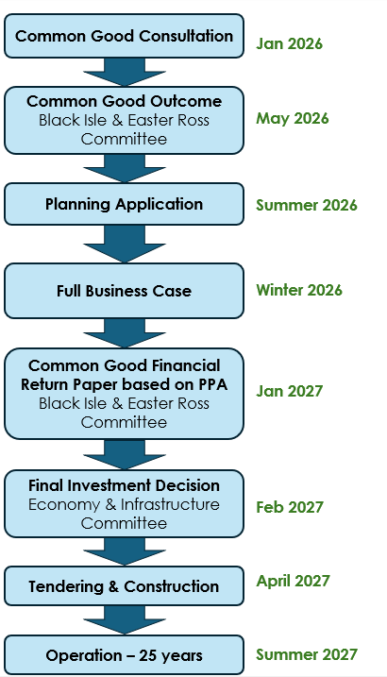
It is anticipated that the project lead times will be as follows:

