THE COMMUNITY EMPOWERMENT (SCOTLAND) ACT 2015

NOTICE OF CONSULTATION ON THE CHANGE OF USE OF COMMON GOOD LAND.

Blairliath Grazings 13-acre site and Blairliath Grazings 4-acre site
Tain, IV19 1PZ

The Highland Council (‘the Council’) propose to change the use of common good properties known as Blairliath Grazings 13-acre site and Blairliath Grazings 4-acre site (‘the Properties’). Before reaching a decision, the Council must have regard to the views of Tain residents via a consultation in terms of Section 104 Community Empowerment (Scotland) Act 2015.

What is being proposed?

The Council wish to develop two ground mounted solar PV array sites on common good land in Tain as part of the Energy Investment and Innovation workstream in the Our Future Highland Delivery Plan 2024-2027 (‘the Proposal’) . The Proposal will generate and distribute renewable energy, supporting local industry and meeting Net Zero ambitions. This will be a commercial development for the Council and therefore will generate income.

For the purpose of the project, the two proposed sites are called ‘Tain North’ (Blairliath Grazings 13-acre site) and ’Tain South’ (Blairliath Grazings 4-acre site) and are shown outlined in red on the plans below.

In terms of Tain North, the Council is considering the development of a 121kWp ground mounted solar PV array which would directly supply renewable electricity to the Scottish Water Wastewater Treatment Works. This will include approximately 220 solar panels installed at the site. The project includes the consideration of a small battery energy storage system to enhance efficiency and resilience. The common good land at this location extends circa. 5.8ha, and the proposal will take up approximately 40 x 85metres (about 0.34ha). This would allow the remaining 5.46ha to continue as grazing land available for future lets.

The Tain South proposal is located to the south of the railway, and this parcel of land has remained unoccupied for several years. The proposal at this location would look to accommodate the entire site which is approximately 4.7ha. This would also be developed similarly as a solar PV array site to supply renewable electricity directly to the adjacent Glenmorangie Distillery. Work is on-going to further develop the energy potential including the number of solar panels required to be installed. The project would also allow the consideration of a small battery energy storage system to enhance efficiency and resilience.
Due to national grid constraints locally and difficulties accessing the Tain sub-station, neither project are being developed to supply electricity to the grid for export. Instead, they will generate renewable energy which will specifically be used for these sites.

The sites would be fenced for security and health and safety reasons and therefore public access restricted.

Further details about the Proposal can be viewed in the additional information document.

Project benefits

For the duration of the project, which is likely to be a minimum of 25-years, the Tain Common Good Fund would receive income and achieving Best Value for the fund. As the proposal is at an early stage, the financial amount is yet to be determined and would be subject to the final array size, return achieved from the sale of electricity (based on a per kwh generated) and build cost to develop the project. The project requires planning permission to progress the next phase which is to develop the business case including the funding and delivery options. Once the options have been considered the financial return to the Tain Common Good Fund will be discussed and confirmed with Local Members.

The proposal will also deliver the following benefits:
- 10% biodiversity net gain above the current baseline of the sites. This will be achieved through the planting of wild-flowers, native tree species and instillation of wildlife nesting boxes.
- Create a revenue stream for the Council.
- The energy generated would be used locally, to increase resilience and reduce costs for the two off-takers.
- The energy generated will come from renewable sources, thereby resulting in a saving of C02 emissions.

What land is affected?

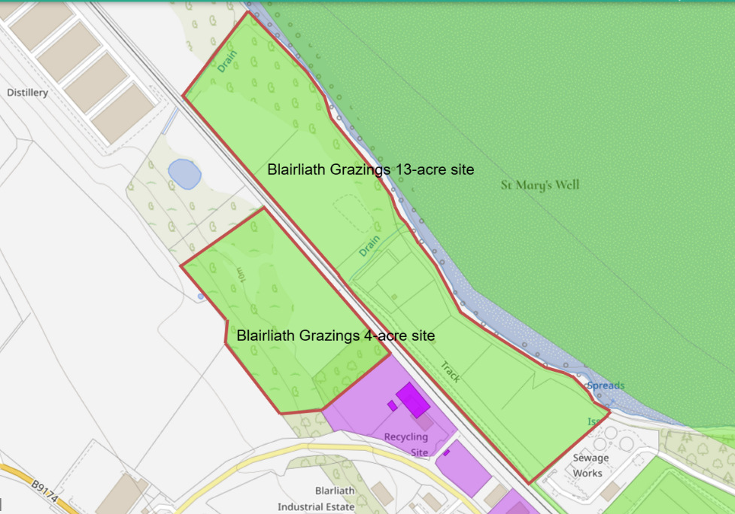
The common good Properties (outlined in red) are located along the railway line adjacent to the Blairliath Industrial site and Dornoch Firth foreshore in Tain. The two proposed sites are called ‘Tain North’ (Blairliath Grazings 13-acre site) and ’Tain South’ (Blairliath Grazings 4-acre site).

Tain North
As shown in the indicative plan below, the Tain North project will occupy approximately 0.34ha within the Blairliath Grazings 13-acre site. The change of use is only applicable for the project area therefore the remainder of the site will continue to be available as grazing lets.

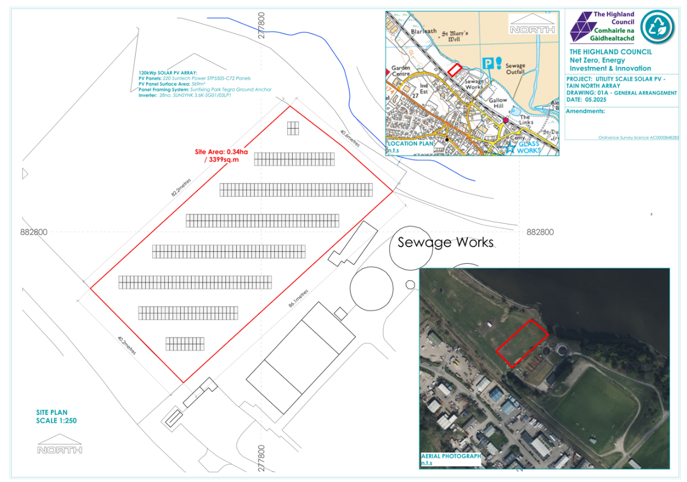

Tain South
As shown in the indicative plan below, the Tain South project is likely to occupy the majority of the Blairliath Grazings 4-acre site.
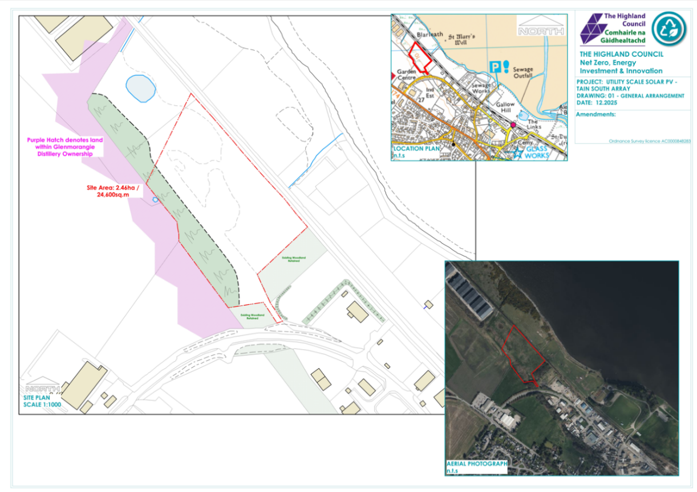

Representations

This consultation seeks views from Tain residents to inform the Council’s decision in respect of the Proposal as described above to:

- Change the use of common good land known as Blairliath Grazings 13-acre site (part of) and Blairliath Grazings 4-acre site.

The consultation is specifically related to common good requirements on the use of the land. Should the proposal proceed, statutory consents relating to the development will be required, including those related to planning.

Key questions:

- What are your views on the Proposal utilising common good land?
- Do you have any views on potential benefits of the Proposal?
- Do you have any issues or concerns arising from the Proposal?
- Do you have any additional comments?

The Council will take all representations received into account in reaching a decision.
A report on the outcome of the consultation will be presented at the Black Isle and Easter Ross Area Committee and a copy of the representations and responses will be published on the Council’s website.

The possible outcomes are:
- The Proposal is approved.
- The Proposal is rejected.

Please submit written representations online, by email or post.
- Online – https://forms.office.com/e/m4zsLFMp6C
- Email: common.good@highland.gov.uk
- Post: Common Good Fund Officer, Highland Council, Headquarters, Glenurquhart Road, Inverness, IV3 5NX.

Timescales

The consultation period will be open for 8-weeks commencing from 19 January 2026. Final written representations must be received by close of play 16 March 2026.

It is anticipated that a report will be presented at the Black Isle and Easter Ross Area Committee on 11 May 2026.

Additional Information

All common good properties fall into one of two categories – alienable or inalienable. Alienable property can be sold, leased or have its use changed in a way that reduces public use without Sheriff Court permission, after the statutory consultation process. Inalienable property is also subject to statutory consultation with the additional requirement to gain court consent in terms of Section 75 Local Government (Scotland) Act 1973 if a question arises whether the property can be alienated.

The Properties related to this consultation is owned by the Council by the title: Mrs Agnes Calder Denoon or Macdonald and Donald Hunter Denoon in favour
of The Ross and Cromarty District Council recorded on the 16th September 1980. It is believed they were purchased with common good funds as investment properties and therefore are alienable common good. This proposal therefore does not require Sheriff Court consent.

