Highlands and Islands – Weekly Local Housing Allowance Rates
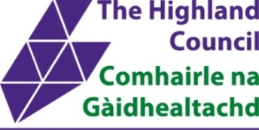
1 April 2026 — 31 March 2027
 | Highlands and Islands  Postcodes: | Argyll and Bute  Postcodes:
 | IV1-28, IV40-49, IV51-56, IV63, KW1-3, KW5-14, PA34, PH19-26, PH30-44, PH49-50 | PA36 & PA38
1 Bedroom with  Shared Facilities | £87.45 | £80.55
1 Bedroom | £109.32 | £103.56
2 Bedrooms | £136.93 | £138.08
3 Bedrooms | £159.95 | £159.95
4 Bedrooms | £195.62 | £276.16

