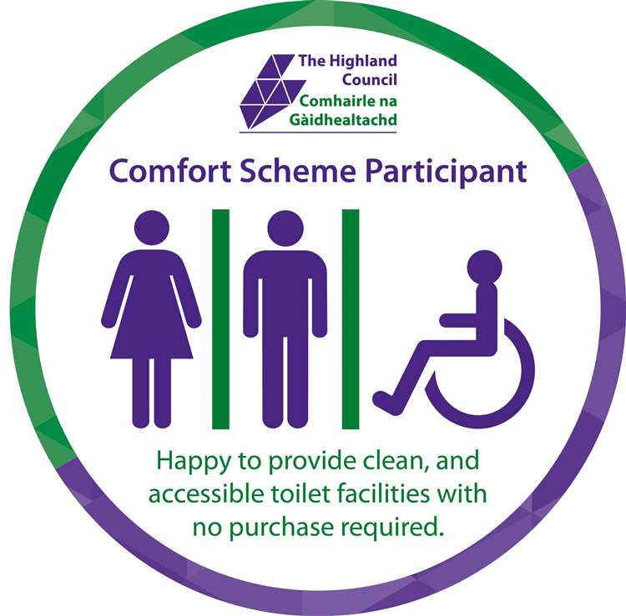

Register interest in becoming a Comfort Scheme provider

To register your interest in becoming a Comfort Scheme provider, please complete this form and return it to:
Email: highlandcomfortscheme@highland.gov.uk

Contact details
Name:
Phone number:
Email address:

Your facilities
Name of business:
Address:
Type of business:
Is your facility already open to the public?
What are your opening hours?
Do you operate all year or seasonally?
If seasonal, which months are you open?
Do you have onsite parking for visitors, motorhomes or coaches?

What facilities do you offer? (tick all that apply)
Unisex toilet
Male toilet
Female toilet
Disabled toilet
Changing Places toilet
Baby change
Shower
Other (please state)

Your interest in the scheme
Why would you like to be considered as a Comfort Scheme provider?
How did you hear about the Highland Comfort Scheme?

After we receive your form
Once we receive your form, we will:
- carry out an initial assessment to check if your facility is eligible
- consider whether there is a need for a new Comfort Scheme in your area
- arrange a site visit if appropriate to discuss the scheme and review your facilities
- assess your facility using our scoring matrix
- determine the appropriate grant rate (if applicable)
- make a recommendation to the Local Area Committee for final approval
Please note: a site visit does not guarantee approval.

