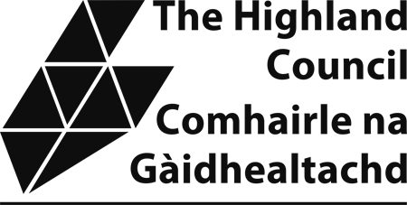

THE FIREWORKS (SCOTLAND) REGULATIONS 2004

APPLICATION FOR DISPENSATION FROM PROHIBITION FROM USING FIREWORKS BETWEEN 23.00 AND 07.00 THE FOLLOWING DAY

Please read the attached guidance notes before completing this form

Please answer all questions (either 2 (a) or (b) or (c)), continuing on a separate sheet if necessary.
 |  | Surname |  | Forename(s)
1. (a) Full name
(Block Letters)
(b) Home Address

(c) Telephone No.
Mobile No.
(d) Email address
(d) Age, Date and Place of Birth |  | Age | Date of Birth |  | Place of Birth
2. (a) Name of Business as a professional organiser or operator of firework displays

- Name of Department of Government or Scottish Executive or name of Scottish Executive Agency
- Name of establishment of the naval, military or air force of the Crown
- Address of (a) or (b) or (c)
3 Description of the proposed fireworks display, national public celebration or national commemorative event

4 Does the display or event have a Public Entertainment Licence  If YES, when was it granted?  When does it expire?  Which Authority granted it?  What is its reference number? |  | YES/NO
5 Please give details of the proposed location of the event by reference to a plan which should accompany this application

6 Please give details of the fireworks proposed to be used at the event.
{see Guidance Notes, Section 4}
7 Please give details of the proposed date or dates and hours during which fireworks shall be used at the event

DECLARATION:

(A) I/We declare that the particulars given by me on this form are correct to the best of my knowledge
and belief.

(B) Data protection - the information you have supplied will be used for the purpose for which you have provided it and any relevant procedures following from this. This data will be maintained in accordance with the Data Protection Act 1998 and will not be passed on or sold to any other organisation without your prior approval unless this is a legal requirement.

Date ..................................... Signature of Applicant .......................................................................

NB Any person who in, or in connection with, the making of this application makes, any statement which he/she knows to be false or recklessly makes any statement which is false in a material particular shall be guilty of an offence and liable, on summary conviction, to a fine.

TO BE LODGED WITH YOUR LOCAL LICENSING OFFICE AT licensing@highland.gov.uk

(fireworksdispensationappform) - fireworks – 01.04.25

