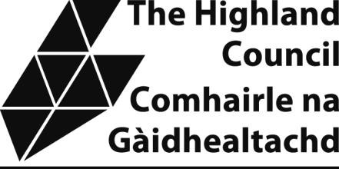

Highland and Islands Skills (HI-Skills) CIC Kintail House, Beechwood Park Inverness, IV2 3BW

ASSET TRANSFER UNDER THE COMMUNITY EMPOWERMENT ACT

ACKNOWLEDGEMENT OF REQUEST FOR REVIEW
This Notice relates to the Community Asset Transfer request made by Highland and Islands Skills (HI-Skills) CIC on the 9th of September 2025, in relation to the Former Torvean Quarry, Inverness IV3 8JN
The Highland Council acknowledges Hi-Skills CIC’s application for review of the decision to refuse the request for Community Asset Transfer, dated 10th of July 2026.
We confirm the date of receipt of the application for Review as 7th of August 2026.
Documents relating to the Review can be inspected online at www.highland.gov.uk/CAT.

Kind regards,
David Haas
Senior Community Development Manager
Housing and Communities
The Highland Council

