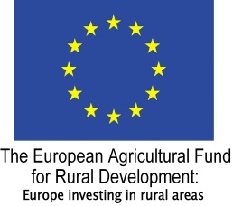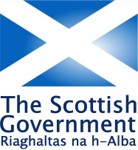

**HIGHLAND LEADER PROGRAMME 2014 – 2020**

**PRODUCING PUBLICATIONS AND PRINTED MATERIALS**

**FAIRER HIGHLAND – ACCESSIBLE CHECKLIST**

This is a checklist that organisations and businesses can use to assess and improve their services in relation to Producing Publications and Printed Materials to ensure they are accessible and inclusive. **Please note these are intended as a guideline only, and may or may not be relevant depending on the nature of your activity.** For more information, please see reference section below.

**General**

* Use simple font types e.g. Myriad Pro, Ebrima, Arial, Tahoma or Century Gothic.
* Font size should be a minimum 12 point and preferably 14 point where possible. Large Print is usually 16 point and above.
* Type weight/font style should be normal or regular.
* Leading should be minimum single space and preferably 1.5 where possible.
* Text alignment should be justified left, and set horizontally.
* Ensure content is clear and uses Plain English
* Use images that are inclusive and reflect diversity
* Avoid images behind or overlapping with text.

**In body text, avoid the use of:**

* Italics;
* Capitals;
* Underlining;
* Hyphenated text;
* Setting text over images or photos;
* Running text around right hand side of images or photos
* Running text across paper fold

**And encourage the use of:**

* Bold (for emphasis e.g. in headings); and
* Increased font size (for emphasis)
* Generous blank spaces in form designs for filling in and generous sized tick boxes
* Clear illustrations/photos and only set text around illustrations if text is placed on the left hand side of the illustration so that the beginnings of text lines are clearly identifiable
* A strong contrast of dark font against light background. Or, if text is reversed out a strong simple font with high contrast against a dark background will be used.

Avoid glossy papers or paper that is too thin and shows text through from the reverse.

If appropriate, consider including a statement, e.g. "To request this information in an alternative format, e.g. large print, Braille, or audio, please contact

References

[Scottish Accessible information Forum](http://www.saifscotland.org.uk/) http://www.saifscotland.org.uk/

[Include Us All – Scotland’s Inclusive Communication Hub](http://includeusall.org.uk/) http://includeusall.org.uk/