MyView Log/Useful Links -

MyView Log in link - https://myview.highland.gov.uk/dashboard/dashboard-ui/index.html#/landing

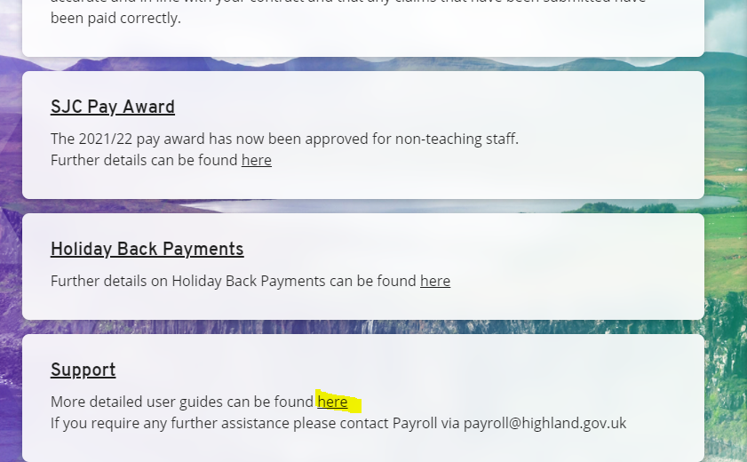

Click on here – takes you to some user guides created for MyView – my understanding is they are maintained by the FSAT team

https://www.highland.gov.uk/downloads/file/24077/updating_my_personal_details - this guide covers updating contact details - e-mail addresses etc.

https://highland-dash.achieveservice.com/service/Register_for_online_HR_and_payroll_services?noLoginPrompt=1 - this is the link issued to register an e-mail address. I am not sure at what stage of the process this is issued but assume it is part of the recruitment process. Payroll should not accept an e-mail address by any other means, but Councillor’s recruitment is treated slightly different.

P45’s for Leavers –

It is mentioned on the Leaver form – as you are not completing Leaver forms as such this would not be known

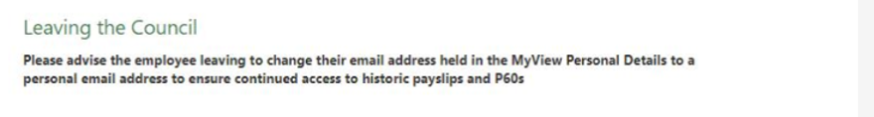
And it is referenced in https://www.highland.gov.uk/peopleandperformance/downloads/file/365/2016_exit_checklist_v5doc
That P45’s will only be available on MyView, again as Councillors follow a different recruitment process this is probably not something as I assume that this is not done for Councillors.

