**Prior To Travelling Abroad**

If you plan to travel abroad during the summer break and wish to use your Highland Council provided laptop and mobile phone you need to ensure you have the correct software and access.

First please ensure your laptop and mobile phone have been used and have all the most recent updates.

On your laptop you will need to have Captive Portal installed. You can check if you have this by clicking on the search at the bottom left and typing in Captive Portal. If it appears as shown, you have the software. If not, please raise a request on the ICT Portal here [https://thc.service-now.com/thc or call 01463383810](https://thc.service-now.com/thc)

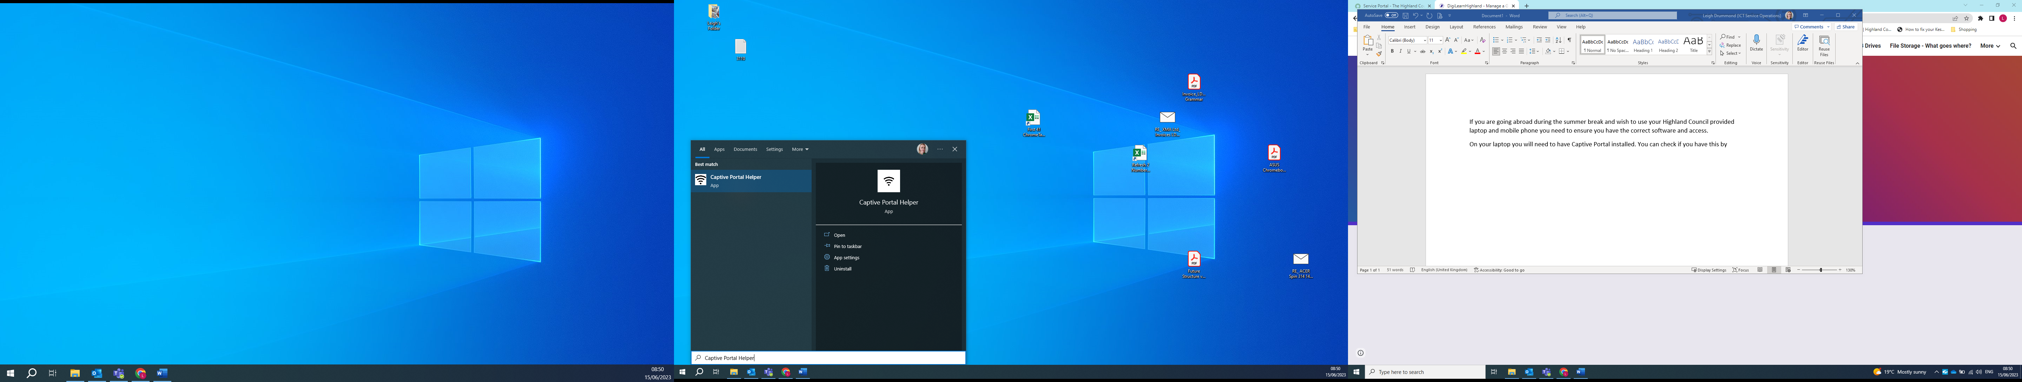

If you would like to use your mobile phone while abroad, you will need roaming added to your contract. If you are unsure if you currently have roaming on your contract, please raise a request on the ICT Portal here <https://thc.service-now.com/thc> or call 01463383810

If you experience problems with using your Highland Council equipment while abroad, please call 01463383810 for assistance. Please do not wait until your return.