To be followed to record Special Leave as a result of Coronavirus
Click on Paid/Unpaid Absence Reporting
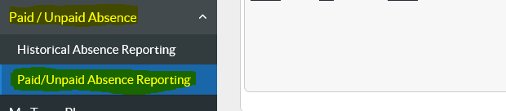

Scroll to the bottom and click on “Create”
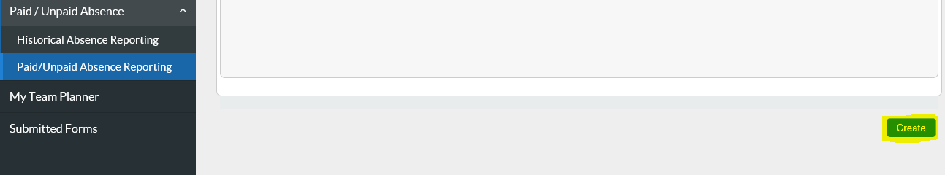
Complete the form with the correct information and click “Next”. Please note you will need to know the Special Leave end date before proceeding.
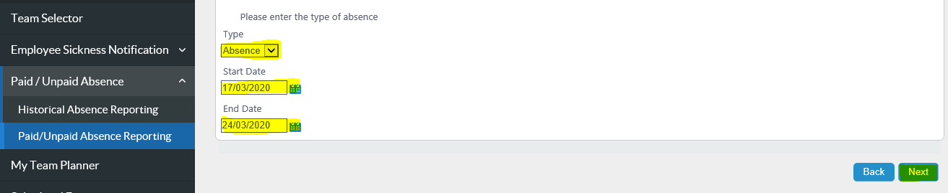
Complete the form with the correct information. For reasons relating to Coronavirus “Paid” should be selected. There are 2 Special Leave absence reasons for Coronavirus - Caring Responsibilities or Self Isolation. Please ensure the correct one is selected depending on the circumstances. Then click submit.

