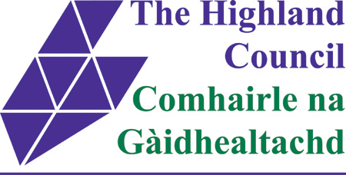
EMPLOYEE REVIEW & DEVELOPMENT (CORPORATE)
Guidance: Complete the eLearning module. Search for ERD in Traineasy
Manager: refresh understanding of process with employee, complete this page, give form to employee along with a copy of induction checklist or last ERD/review form and meeting date.
Employee: Complete section 1. Consider sections 2 and 3. Add notes if you wish. Return form to your manager.
Further information on HR Microsite:
ERD Model Organisational Values Model Competency Frameworks ERD Guidance Health and Safety Competencies
Personal Details
Employee Name: | Line Manager Name:
Employee Post Title: | Line Manager Post Title:
Employee Pay Number:
Review Period: ____________to____________

ERD Employee Reflection

Section 1 – Employee: consider each statement and make some notes. Manager to add notes for discussion at ERD meeting

1. What do you consider to be your work achievements this year?
2. What has not gone so well and why?
3. Have you completed the Council’s corporate mandatory training required for your role?
4. What issues would you like to raise with your manager about the coming year?
5. What could your manager do differently or change in the work environment to assist you in your job?
6. Do you have any future plans that you wish to discuss with your manager?

ERD - Reflecting on the Councils Values
Section 2 – discuss what the values and behaviours mean in relation to the employees work and agree any areas for development. Refer to the Competency Frameworks

How have you contributed to the council being Ambitious |  |  | How have you contributed to the Council being Sustainable |  |  | How have you contributed to the Council being Connected
We will be performing and forward thinking, embracing change and challenge. |  |  | We will be efficient, resourceful and adaptable to deliver for our communities and environment. |  |  | We will work together with communities, staff and partners for the best outcomes for Highland.
Forward Thinking | Can Do | High Performing | Efficient | Resourceful Flexible | Affordable Transparent | Engaging | Listening | Working Together

Discuss one behaviour that you do well.
Discuss one behaviour that you would like to develop.

Agreed ERD Plan: _______________to ______________
Section 3 – Manager to prepare and discuss this section with employee during the meeting, complete form and send to employee to check, sign and
return. Please refer to the plan regularly to guide achievement of actions.
Agree review date.
Employee: when you have completed ERD with your manager please go to Traineasy and answer YES in the ‘Log your ERD’ quiz
Manager – for staff without access to Traineasy please email learningmanagementsystem@highland.gov.uk
TOPIC | ACTION | COMPLETION DATE
Health, Safety & Wellbeing
Including, mandatory training, risk assessment, facilities, attendance, health issues, adjustments, workplace stressors, role of mental health rep
Workload & Objectives
Including work plans, workload, changes to working practices, new processes and procedures
Skills & Development
Role specific skills, competencies, changed skill requirements, personal development, career development, coaching
Performance
Progress against previous targets, feedback on good work, lessons learned, professional practice and standards
Future Plans
Future work requirements, opportunities, employee plans and aspirations

Employee Signature: _______________________________________________________________ Date: ___________________________
Manager Signature: _________________________________________________________________ Date: ___________________________

