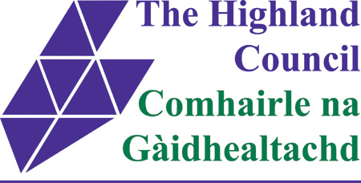
EMPLOYEE REVIEW & DEVELOPMENT
(NOTE OF REVIEW MEETING)
Personal Details
Employee Name: | Line Manager Name:
Date:

Action Points from last Review:

Topics for Review: | Yes / No
Health, Safety & Wellbeing
Workload and Work Objectives
Performance
Skills and Development

Completed by ☐

Note of Discussion Points:

Actions | Who | Date

Employee Signature: __________________________________________________ Date: _______________________
Line Manager Signature: _______________________________________________ Date: _______________________

Completing the Review – Some possible issues for discussion are provided below
NB Not all topics need to be discussed at each review. Discussion should focus on the issues most relevant to the employee and the job role at the time of the review. However, all topics must be covered at least once every 12 months.

Health, Safety & Wellbeing
- Health & safety requirements (including mandatory training)
- Issues from job role/workplace risk assessment (remember risk assessment and adjustment for pregnant staff)
- Health issues (remember adjustments for disability or other needs)
- Attendance at work
- Working relationships including those with clients/contractors
- Workplace stressors
- Working environment and facilities
Workload & Work Objectives
- Work plan and actions from last review
- Next period’s work plan
- Workload management - address level of workload i.e., insufficient, sufficient, too much
- Changes to working practices affecting work – may inform NWOW Team Agreement
- (procedures, organisational developments, standards, legislation)
- Any support issues arising
- Skills and Development
- Progress with role specific requirements
- Changes to skill requirements (as a result of new tasks, changes to working practices etc.)
- Training and development required (as a result of issues discussed in Health, Safety & Wellbeing; Workload and Work Objectives and Performance)
Performance
- Progress against targets and expectations
- Honest praise for work completed well
- Lessons learned and areas for improvement
- Professional practice and standards
- Assessment of values and competencies
Future Plans
- Future work developments likely to impact on the employee
- Employee plans or aspirations that might likely to have an impact in the workplace

