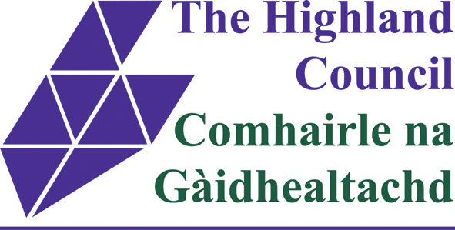 |  |  | Keeping in Touch (KIT) Days  Notification Form
Before completing this form, and If you have not already done so, you should read the guidance on KIT days in the Maternity or Adoption Provisions Guidance Notes and the KIT Days FAQ document.
The form should be completed by the employee, authorised by their manager/Head Teacher, forwarded to the Staffing Unit (for all teaching and non-teaching staff based in schools only) and then forwarded to Payroll with a copy retained by their manager.

Name of Employee: |  |  |  | Payroll Number  (8 digits):
Address: |  |  |  | Job Title:
Service: |  |  |  | Location/School:
Date Maternity or Adoption Leave Commenced: |  |  |  | Date of Baby’s Birth or Placement of Child for Adoption:
A KIT day is any day during adoption or maternity leave where work-related activity is undertaken by the employee, including attendance at training, meeting, or a conference.
A maximum of 10 KIT days can be taken without losing out on Statutory Maternity Pay (SMP), Statutory Adoption Pay (SAP), Maternity Allowance (MA) or ending the period of adoption or maternity leave.
KIT days cannot be taken during the first 2 weeks following a baby’s birth (compulsory maternity leave), and must be agreed in advance between the employee and their manager.

Date of KIT Day and number of remaining KIT days (out of a max. of 10) | Hours actually worked during the KIT day (should be no greater than your normal daily working hours, excluding a lunch break if appropriate) |  |  |  | Employee’s signature |  |  | Date of signature
AUTHORISATION BY MANAGER / HEAD TEACHER/STAFFING UNIT
Signature: |  |  |  |  |  | Date:
FOR PAYROLL USE ONLY
Input by: |  |  |  |  |  | Date:
Checked by: |  |  |  |  |  | Date:

