The Highland Council

Equal Pay Audit 2019

2019 | Combined Gap | Full Time Gap | Part Time Gap
All employees | +5.8% | -17.4% | +23.2%
Non-Teaching employees | +12.0% | -8.3% | +22.3%
Teaching employees | +4.5% | +4.6% | +8.6%
SJC employees | +13.5% | -6.8% | +23.1%

 | Combined Gap |  | Full Time Gap |  | Part Time Gap
Average Hourly Rates 2019 | Male | Female | Male | Female | Male | Female
All Employees | £16.11 | £15.18 | £16.53 | £19.43 | £14.18 | £12.69
Non-Teaching Employees | £13.45 | £11.84 | £13.88 | £15.03 | £11.49 | £10.79
Teaching Employees | £23.98 | £22.91 | £24.38 | £23.25 | £22.13 | £22.29
SJC Employees | £13.36 | £11.56 | £13.76 | £14.69 | £11.47 | £10.58

1. Context

1.1 The main provisions of the Equality Act came into force on 1 October 2010.
The Act brings together the previous strands of equality and discrimination legislation and aims to simplify and strengthen the law.

1.2 The Act also introduces a general duty on public bodies to give due regard in all their work to the need to:

• Eliminate unlawful discrimination, harassment and victimisation and other conduct that is prohibited by the Equality Act.
• Advance equality of opportunity between people who share a relevant protected characteristic and those who do not.
• Foster good relations between people who share a protected characteristic and those who do not.

In addition, specific duties introduced in Scotland in 2012 by Regulations
require the Council to publish information on the Council’s equal pay gap.

1.3 Guidance on meeting the requirements of the various duties is provided by the
Equalities and Human Rights Commission (EHRC) and supported by Close the Gap. Close the Gap is an organisation, funded by the Scottish
Government, working in partnership with the EHRC and the Scottish Trades
Union Congress to guide and assist employers. All pay gap calculations are based on their guidance.

1.4 An organisation’s gender pay gap is the difference between the average male and female pay rates. It is calculated by dividing the average female hourly pay rate by the average male hourly pay rate. The full time gender pay gap is the gap between the average hourly pay rate of female employees who work full time and male employees who work full time. The part time gender pay gap is the gap between the average hourly pay rate of female employees who work part time and male employees who work full time.

1.5 The Council is required to publish the gender pay gap between male and female employees. It is also required to publish this data separately on employees in Education (Teaching employees) The EHRC and Close the Gap also strongly advise publishing separate full time and part time gender pay gaps. It is considered that any pay gap of 5% or more is considered significant and in need on further analysis.

2. Gender Pay Gap

2.1 Background:
The 2017 Equal Pay Audit, carried out in partnership with the Trade Unions, identified the following equal Pay Gaps:

2017 | Combined Gap | Full Time Gap | Part Time Gap
All employees | +7.2% | -13.9% | +23.8%
Non-Teaching employees | +12.8% | -8.8% | +23.2%
Teaching employees | +4.8% | +4.3% | +8.6%
SJC employees | +13.6% | -8.2% | +23.6%

(A positive figure denotes a gap to the advantage of male employees. A
negative figure denotes a gap to the advantage of female employees.)

2.2 Analysis of this data suggested that:

a. Both Scottish Joint Council (SJC) and Teacher pay and grading structures are robust and support equal pay.

b. Significant workforce gender segregation in SJC Job Families (Business Support, Personal Care, Technical and Practical), Craft and Teaching posts coincide with significant part time pay gaps.

c. Lower availability of part time working in SJC grades HC6 and above coincides with a significant SJC Part Time pay gap.

d. Lower availability of part time working in promoted teaching grades coincides with a Teaching Part Time pay gap.

2.3 Previous audits found that the following issues could contribute to pay gaps.

a. Vertical gender segregation (disproportionately low number of women in senior posts) in Teaching posts and in SJC Business Support and Management posts.

b. Horizontal gender segregation in teaching posts (disproportionately low
number of women Head Teachers in Secondary Schools).

c. Lower uptake of part time working opportunities in senior teaching posts and in SJC posts graded HC06 and above.

d. Horizontal gender segregation (males in Community Works and females in Catering, Cleaning and Caring posts) within Technical & Practical posts.

2.4 A number of actions continue to been taken to address gender segregation and the availability of part time work in senior grades. For example:

a. Female role models in male dominated job groups have been identified and achievements publicised in corporate communications.

b. Where service delivery allows vacancies will be advertised as "suitable for flexible working hours up to 35 per week" to encourage applications from candidates who wish to work on a part time basis part time applications.

c. Job Descriptions and Person Specifications have been reviewed to ensure that they contain no gender bias.

d. Services have reviewed workplace facilities to ensure that both genders are adequately catered for

e. Significant areas of gender segregation are monitored and reviewed to identify and address any barriers to employment.

f. Strategic workforce planning to address and further promote flexible working arrangements that support women to progress their careers.

g. Working with Close the Gap (working towards Equally Safe at Work accreditation)

2.5 These actions coincide with a significant general improvement in the Highland
Council’s gender equal pay gaps in the 2 years since the last audit. Going into
2019 the gaps are as follows:

2019 | Combined Gap | Full Time Gap | Part Time Gap
All employees | +5.8% | -17.4% | +23.2%
Non-Teaching employees | +12.0% | -8.3% | +22.3%
Teaching employees | +4.5% | +4.6% | +8.6%
SJC employees | +13.5% | -6.8% | +27.1%

(A positive figure denotes a gap to the advantage of male employees. A
negative figure denotes a gap to the advantage of female employees.)

2.6 Improvements in these pay gaps over the period 2017-2019 are as follows.

Improvements 2017 - 2019 | Combined Gap | Full Time Gap | Part Time Gap
All employees | 1.4% | -3.5% | 0.6%
Non-Teaching employees | 0.8% | 0.5% | 0.9%
Teaching employees | 0.3% | -0.3% | 0.0%
SJC employees | 0.1% | 1.4% | 0.5%

Trends in the Council’s gender pay gaps, since these were first recorded in 2013 are set out below.

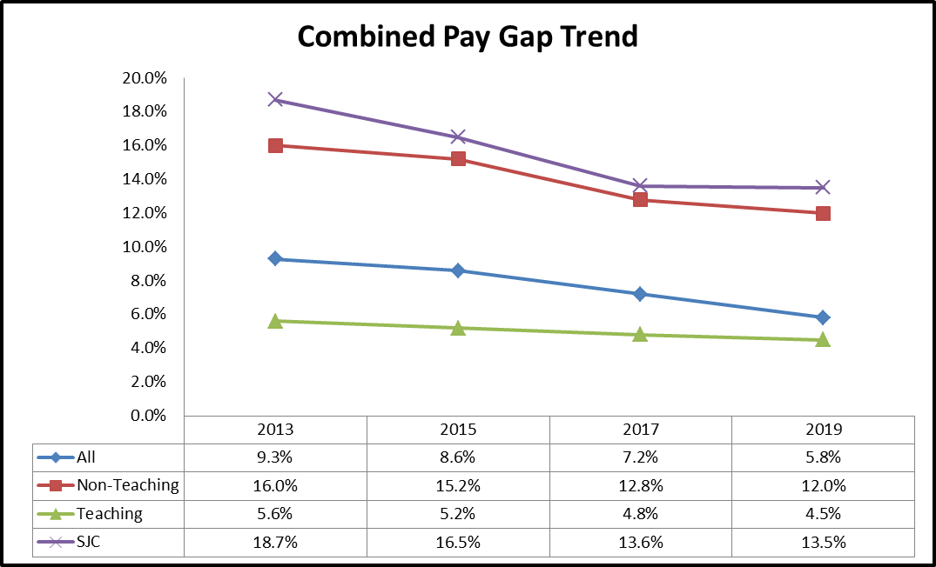

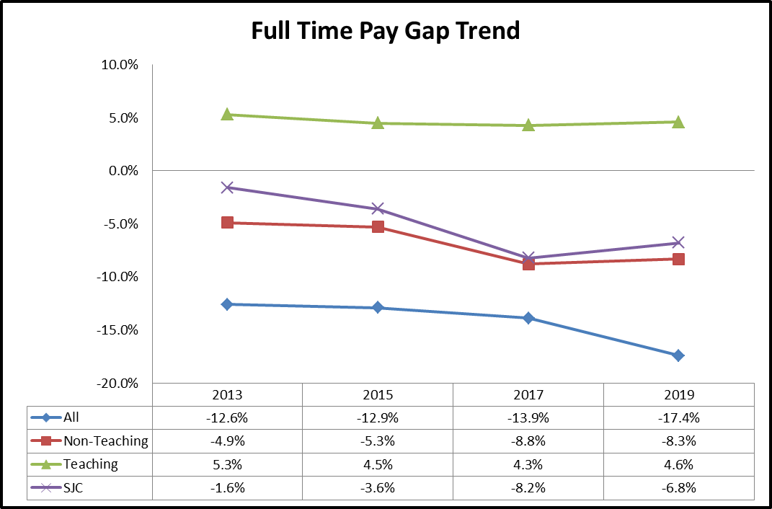
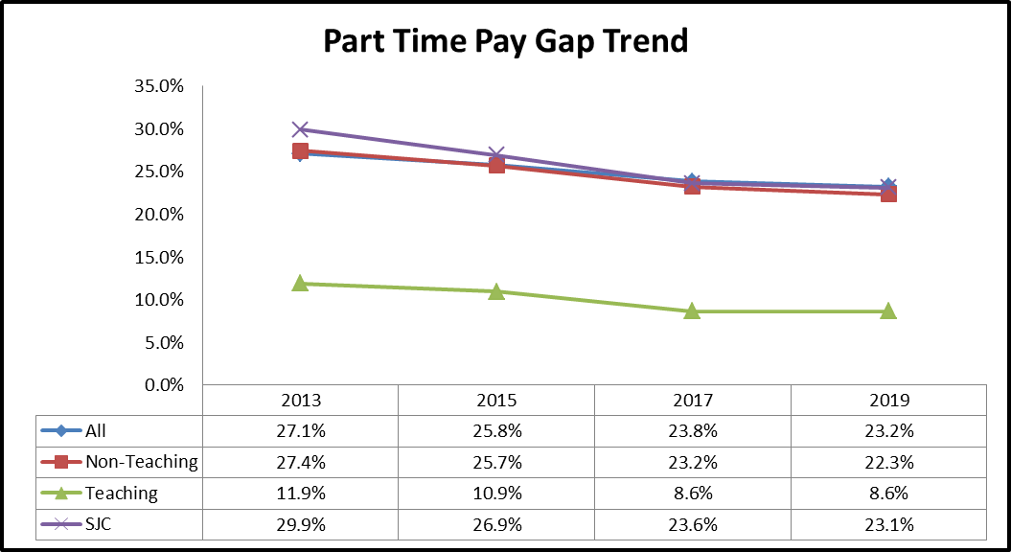

2.7 The Council’s pay gaps are interesting in that the full time pay gaps are generally to the benefit of women. The part time pay gaps for all employees are more in line with what would be expected given the make-up of our workforce. This marked difference between the full time and part time gaps
suggest that one of the underlying reasons for the combined gap is the greater
availability of part time and term time work in the lower pay grades.

2.8 As part of the Council’s commitment to Equally Safe at Work accreditation we also analyse our median pay gaps. We are currently working with Close the Gap to understand these and how they can assist us in informing future action.

2019 Median | Female | Male | Gap
Combined Gap | £12.28 | £13.98 | +12.2%
Full Time Gap | £19.92 | £13.98 | -42.5%
Part Time Gap | £10.73 | £13.98 | +23.2%

Highland Council do not pay bonus at all. Allowances are based on hourly rates already analysed in the hourly pay gaps.

The proportion of men and women in each pay quartile is as follows:

Quartile | Male | Female
Q1 | 27.1% | 72.9%
Q2 | 27.4% | 72.6%
Q3 | 24.4% | 75.6%
Q4 | 23.0% | 77.1%

Pay gap data for our ALEO Highlife Highland are at Appendix 1.

3. Women in Management

3.1 In addition to the actions set out in 2.5, over the period from 2017 the Council has taken specific actions to reduce the pay gap for women in management positions. These include:

a. Creating and supporting an on-line learning resource for female employees interested in preparing for supervisory and management roles.

b. Improving the Women into Management programme

3.2 The on-line learning material sits within the Council’s My Online Learning platform and provides 14 e-learning modules across a range of topics that female staff have identified as of specific interest. These include networking and influencing skills; presenting yourself; career development and challenging yourself.

3.3 The Council’s Women in Management Programme provides a two day workshop for new and aspiring women managers and includes confidence building, assertiveness, presentation, goal setting and career development. The programme also includes speakers who are successful women managers from the public and private sectors.

3.4 The Highland Council Mentoring scheme, although open to all, is specifically targeted at women wishing to enter or progress a career in management. Advisers work with those who wish to join the scheme to understand their goals and requirements before matching them with an experience mentor who is a senior manager in the Council.
3.5 The combined pay gap relating to SJC Management employees has reduced year on year from 2013 to 2017. There has been a change in the figures with the pay gap increasing from 3.5% in 2017 to 8.7% in 2019. However, whilst the gap has increased, the number of women in management grades has not been adversely affected.

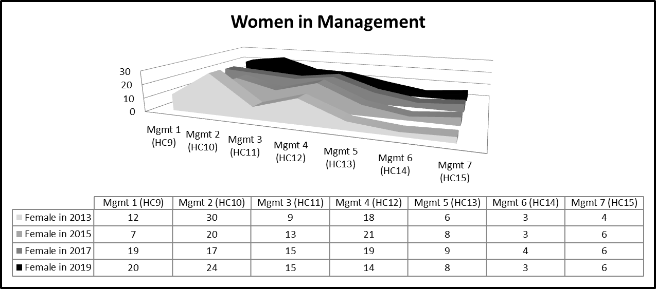

3.6 In 2019 50% of the managers employed in SJC Management posts are women. However, there is significant difference in the distribution of male versus female managers with female managers being more concentrated in the lower graded management grades.

4. Next Steps

4.1 Although significant improvement have been made since the first Equal Pay Audit in 2013 it is important to maintain momentum. This will be particularly important in the coming years exacerbated by the difficult financial situation and the continued need for a reducing workforce.

The creation of a strategic workforce planning programme will drive change in how the organisation designs roles to meet future service requirements. The distributed nature of the workforce is significant, with more than 95% of employees’ working out with the Council’s Inverness Headquarters. Workforce planning will increase opportunities through flexibility and supported transition with the potential to effect gender segregation within roles.

Appendix 1 – Highlife Highland (ALEO) Gender Pay Gap Report

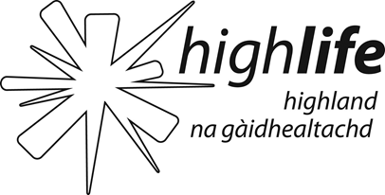 | Gender Pay Gap Report 2018  Approved by HLH Board – 4/9/18

High Life Highland is a charity registered in Scotland, formed on the 1st October 2011 by The Highland Council to develop and promote opportunities in culture, learning, sport, leisure, health and wellbeing across 9 services throughout the whole of the Highlands, for both residents and visitors.
The Gender Pay Gap data supplied is correct for all employees in post with High Life Highland on 31 March 2018.

On that date there were 932 relevant and full-pay relevant employees, 321 (34%) males and 611 females (66%).

The figures set out below have been calculated using the standard calculations used in the Equality Act 2010 (Gender Pay Gap Information) Regulations 2017

Pay and Bonus Gap

Difference between male and female
 | Mean | Median
Hourly fixed pay | 5.3% | 7.2%
Bonus paid | 0% | 0%
- The table above shows High Life Highland’s mean and median gender pay gap based on hourly rates of pay.
- There were no bonuses paid to any staff in the year up to 31 March 2018.
- Across all employers who reported their Gender Pay Gap for 2017/18, High Life Highland’s mean pay gap of 5.3% is 9.2% less than the national average of 14.5%.¹
- With a 7.2% median pay gap, High Life Highland is 4.9% below the national average of 12%¹ as reported for 2017/18

¹ House of Commons briefing paper No. 7068 6 April 2018 http://researchbriefings.files.parliament.uk/documents/SN07068/SN07068.pdf

Pay Quartiles by Gender
Quartile | Males | Females | Description
1 | 27% | 73% | Includes all High Life Highland employees whose standard hourly rate places them in the 1st and lowest pay quartile.
2 | 34% | 66% | Includes all High Life Highland employees whose standard hourly rate places them below the median pay in the 2nd pay quartile.
3 | 42% | 58% | Includes all High Life Highland employees whose standard hourly rate places them above the median pay in the 3rd pay quartile.
4 | 35% | 65% | Includes all High Life Highland employees whose standard hourly rate places them in the 4th and therefore highest pay quartile.
- The table above sets out the gender distribution at High Life Highland across four equally sized quartiles, each containing 233 employees.
- With an overall split of 34% male to 66% female within High Life Highland each quartile shows a gender distribution which very closely matches this overall ratio.

High Life Highland is committed to the promotion of equality of opportunity in its employment practices. It is committed to offering roles on flexible working patterns, with a range of options such as part-time working, alternative working hours, home working and shared parental leave.

The Charity’s Equal Opportunities policy states that it intends that no job applicant or employee shall receive less favourable treatment because of sex, marital or family status, age, ethnic origin, disability, race, colour, nationality, religion, belief, sexual orientation, gender reassignment or any other non job related factor.

High Life Highland is also confident that males and females are paid the same rate for the job regardless of gender (or any other difference). Employees are remunerated according to set pay scales and terms and conditions which are negotiated nationally, through The Highland Council, by the Scottish Joint Council for Local Government Employees.
High Life Highland’s gender pay gap compares favourably to national statistics but it is committed to monitoring and reducing the gap wherever possible, whilst also recognising that it has no direct control over the gender of applicants for particular job types or an individual’s career choices.
I confirm the data reported is accurate.
Ian Murray
Chief Executive

