The Highland Council  Interview Expenses Claim Form | 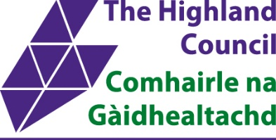
Use the tab key to move between fields. The form may then be saved and printed or emailed.

Post
Post Title and Ref. No.: |  |  | Name:
Service: |  |  | Address:
Date(s) of Interview:
Bank Sort Code:  Bank A/c Number: |  |  | Bank A/c Name:
 |  |  | Email Address:

Details of Expenses Incurred
Your expenses will be paid as soon as possible after you submit this form. No payment can be made on the date of the interview.
If you are the successful candidate expenses will not be paid until after your commencement date. If you fail to commence employment, then no reimbursement will be made.

Please email form and ALL Receipts to recruitment.enquiries@highland.gov.uk
Transport*/Travel: |  |  | Amount:
Meals: |  |  | Amount:
Accommodation:** |  |  | Amount:
 |  |  | Total of Claim: |  |  | £
RECEIPTS MUST BE ATTACHED FOR ALL EXPENSES BEING CLAIMED.  * This should be 2nd Class Rail, or where not practicable,  reasonable other public transport cost. Car mileage, at a  rate detailed below, will only be paid where public  transport is not possible. Otherwise, candidates travelling  by car will be paid 2nd Class Rail Fare. Rail fares should be  based on the cheapest rate available, including special  arrangements currently in operation by rail franchises e.g.  APEX, Supersavers, Savers, etc.  ** Maximum allowances payable for attendance at  interviews are as detailed: |  |  |  | ALLOWANCES  (exact amount will be paid upon production of receipts up to the maximum limits below)
 |  |  |  | Bed & Breakfast |  |  | £110.00
 |  |  |  | Dinner |  |  | £25.00
 |  |  |  | Car Mileage (per mile) |  |  | £0.45p
I have incurred the above expenses and claim reimbursement subject to the provisions contained in the letter calling me for interview and as given on this claim form.
Signature: |  |  |  |  | Date:

