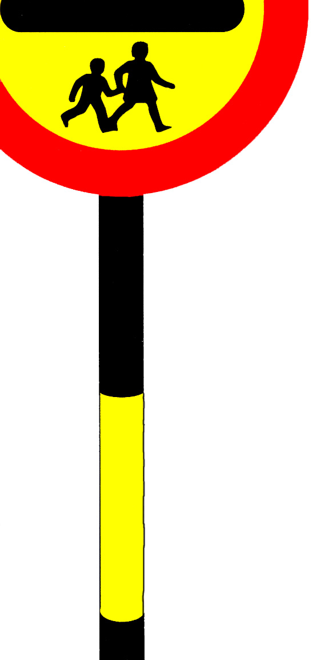

School Crossing Patrol Service

Handbook for School Crossing Patrols

June 2010
SCHOOL CROSSING PATROL HANDBOOK

Name: …………………………………………………..

Location: …………………………………………….....

Your Head Teacher / Supervisor is: ……………………………………

Office Telephone Number: ……………………………

Mobile Telephone Number: …………………………….

Your Supervisor will be on call from am to pm
Monday to Friday during term time.

Your duty times are:-

From: ………………………..To: ……………………..

From: ………………………..To: ……………………..

From: ………………………..To: ……………………..

If you operate flashing warning lights you will be allocated an
additional 15 minutes per day.

Foreword

Welcome to your post of School Crossing Patroller. You will be performing a very important and responsible job, ensuring the safety of children across the road on their way to and from school and providing assistance to adults when required.

This handbook contains important information and guidance, including legal requirements, which you must follow at all times. Please read the contents carefully and operate in accordance with the instructions given.

I hope you will be happy performing your duties and take satisfaction in the knowledge that you are playing a valuable role in the community.

1: Hours of duty

Your hours of duty means the times you work at the crossing point to which you have been appointed. These hours have been determined to the requirements for each crossing point and may be varied as circumstances alter. Therefore, do not be afraid to suggest any changes in times to your Head Teacher/Supervisor if you feel the current hours do not meet the requirements. However, if you are approached by a member of staff from the school and requested to change your times of duty or work additional hours, please ask them to contact the Head Teacher, who must authorise any variations.

You must be punctual in your time of arrival at your crossing point and remain there for the full length of the time indicated on page 2. You must never leave before the end of your duty time.

Children are often late for school and late-comers are more inclined to take chances than those with plenty of time. Bad time-keeping is considered to be a most serious breach of working conditions for SCPs.

You must not, under any circumstances, change your hours of duty. Any changes must only be made by the Head Teacher/Supervisor.

2: Power to stop traffic

The Road Traffic Regulation Act 1984 gives a School Crossing Patrol, wearing the approved uniform and displaying the prescribed sign, the power to stop traffic. An SCP operating outside these conditions has no legal power to stop traffic.

Section 270 of the Transport Act 2000, which came into force on 30 January 2001, allows SCPs to stop traffic to help anyone (child or adult) cross the road.

3: Uniform

To comply with the law the following items of uniform must be worn at all times when on duty: Official hat and winter or summer coat as supplied.

To comply with health and safety law, all uniform coats meet with the requirement of the relevant British Standard (currently BS EN 471:2003 + A1 2007) and the standard agreed by the Home Office. Therefore, you must not make any alterations to the uniform issued to you. You must not wear any other clothing over your official uniform and you must wear your coat fastened at all times to give maximum warning of your presence in the carriageway. You must not fasten any badges or other decoration to your uniform coat and hat.

In addition to the approved uniform, you may be supplied with other items, such as overtrousers, hats and gloves. If provided, you are strongly advised to wear them to help protect you against bad weather, but this is at your discretion. For your personal safety you must wear sensible footwear at all times.

The uniform provided must not be worn at any other times, except when travelling to or from your site.

You are responsible for keeping your uniform clean and readily available in a safe place. This maintains the standard of the service and makes you as visible as possible. Always wash your uniform according to the manufacturer’s instructions on the label.

Remember to contact your Head Teacher/Supervisor immediately if you require an item of uniform replaced.

4: School Crossing Patrol Sign

Your sign is an important part of your SCP uniform and, as such, is your responsibility and must also be kept in a safe place. Your sign meets the specification laid down in ‘The School Crossing Patrol Sign (England and Wales) Regulations 2006’ and therefore must not be altered in any way. Do not add stickers or any form of writing or decoration to your sign as it will no longer be a legal road sign. You are the only person who should use the sign.

Your sign must always be used when stopping traffic to enable pedestrians to cross the road.

If your sign is stolen or breaks and cannot be used you must contact your Head Teacher / Supervisor immediately to get a replacement sign ready for your next duty period. You may escort children to cross the road but you cannot act as an SCP.

Failure to wear the required uniform and display the prescribed sign means that an SCP is operating illegally and may become personally responsible for any claims.

5: Appearance and Behaviour

When on duty, you are required to be neat and tidy in your appearance, to be properly dressed in your official uniform and carrying your SCP sign.

Please remember that motorists and pedestrians will judge your authority and efficiency by your appearance and your standards will reflect on all SCPs as well as the Council. When on duty you must remain alert and attentive, clean, neat and tidy.

Avoid any distractions or activities that could divert your attention from your important task of seeing pedestrians safely across the road. You should not get distracted by:
- Talking to friends at your crossing
- Using a mobile phone or mp3 player
- Bringing your own children to your site, unless they are on their way to and from school

You are expected to be courteous at all times and avoid becoming involved in arguments. Do not forget that you are representing the Council as a whole. Remember to treat people in the manner you would expect to be treated. If you do this, you are unlikely to do anything wrong.

Alcohol and Drugs

Never consume alcohol before going or whilst on duty. Think about how much you drink in an evening as alcohol may still be in your system the next morning. Drinking alcohol will impair your performance and judgement and endanger you and other people.

You must not work under the influence of drugs or medicines that might affect your performance. When taking prescribed medication, ask your doctor if it is safe for you to carry out your duties. If you are taking other medicines, ask the pharmacist for advice. If your performance is impaired by drink or drugs this will be viewed very seriously by the Council and may result in disciplinary action being taken against you.

The Council has a no smoking policy. You must not smoke on duty or while wearing your uniform.

6: Operating at your crossing point

It is important that you arrive at your site in time to start your duty and you do not leave until your duty is finished. You are responsible for the safety of children and other pedestrians once they arrive at your site. Although crossing children is the main purpose of your job, you may offer assistance to any adults who wish to cross and can stop traffic for them regardless of whether children are present.

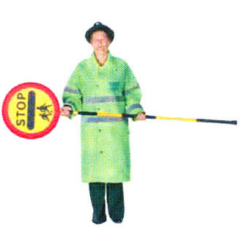
Be clear and firm in your instructions to children. When they approach your site, hold the pole horizontally to form a barrier and tell children to wait on the footpath until instructed by you to cross. Keep your pole like this until you are ready to stop the traffic.

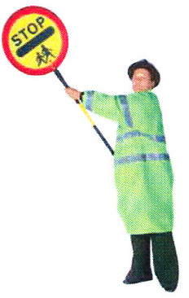
To stop traffic, wait for an adequate gap and raise your sign high, clearly showing the face of the sign to drivers. Give drivers time to stop and be decisive. Making eye contact with drivers would be beneficial. Don’t forget that in wet conditions traffic will take longer to stop. Large vehicles will also take longer to stop and it may be better to allow them to pass. Try to avoid stopping emergency vehicles.

Your sign is your only authority to stop vehicles. Never attempt to use hand signals.

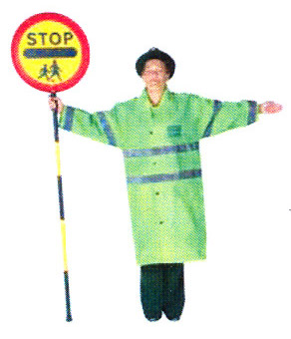
Once the traffic has stopped in both directions, walk to the centre of the road with your sign upright and clearly displayed. Position yourself in the centre of the road displaying the sign in an upright position. Extend your other arm in a horizontal position to form an additional barrier to traffic behind you. This position makes you as visible as possible to all traffic.

Now you are in the centre of the road with all vehicles safely stopped, you can instruct the waiting pedestrians to cross. Ensure everyone walks in front of you so you can see they are safe. Do not leave the centre of the road until everyone has reached the pavement. When you have finished crossing the children, return to the pavement, keeping your sign upright. Try and ensure the traffic remains stationary while you are in the road. Don’t forget to thank the motorists that have stopped for you. You should not hold up traffic unnecessarily while waiting for children to reach you. Allow traffic to flow between crossing groups of children.
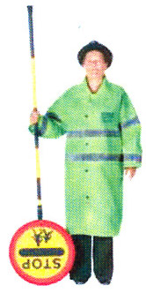
When you are back on the pavement, lower the sign head to the down position to avoid confusing motorists.

Remember, be positive in all your actions and give instructions in a polite but firm manner.

Operating at light controlled crossings

When operating at a Pelican, Puffin, Toucan or Traffic Light crossing, never begin crossing pedestrians until the green man phase starts. This means the traffic lights will be on red for the traffic.

Operate as normal by going to the centre of the road and then advising pedestrians to cross. Once the green man goes out, instruct any pedestrians not yet on the road to wait on the footpath. You should remain in the road with your sign held high until all the pedestrians have crossed, and then return to the footpath.

You must do your best to clear the crossing before the red man phase because this will indicate the lights are green for traffic.

You must use your sign as normal.

7: Flashing Warning Lights

At some sites flashing warning lights are installed on one or both approaches to the crossing point.

These may switch on and off automatically. If not, your Supervisor will advise you on how to operate them and provide you with any equipment necessary to switch them on and off. It is your responsibility to switch them on at the beginning of your duty time and off at the end of your session. The lights are there for your protection and should be used on every duty period. It is essential they are switched off at the end of your duty as motorists may disregard them if they do not seem to serve a useful purpose.

It is your responsibility to check regularly that the lights are operating correctly and report any faults to your Head Teacher / Supervisor.

8: Accidents
As you are working on the highway there is a small chance that an accident may happen on or close to your crossing. If this does happen you should take the following action:
- If you think that a child or adult may be seriously injured do not move them. If possible cover them with some thing warm – not your uniform coat.
- Make sure a responsible person contacts the emergency services.
- Make sure someone stays with the casualty and protect the scene if possible, but do not put yourself in danger.
- Continue your work as a Patrol, making sure children and other pedestrians are crossed safely.
- As soon as your duty period is finished you should contact your Supervisor and inform them of the details.

Your main responsibility is the safety of those children and other pedestrians that cross with you, not to deal with casualties, direct traffic or become involved with the incident.

If you are injured and cannot continue your duties, you must seek medical attention as soon as possible. Wherever possible you should inform your Supervisor before leaving the crossing point. If this is not possible ask someone else to contact them for you. If you are able to continue your duty you should visit your doctor or hospital A&E department as soon as you finish work. Inform your Supervisor as soon as possible.

Following an accident you should not give statements to anyone other than the police, your Supervisor or a Council health and safety officer.

9: Incidents
Do not become involved in any arguments with drivers or other people at your crossing point. Try to remain calm and courteous when carrying out your duties, even if provoked.
Remarks or statements made on the spur of the moment may involve you and the Council in legal proceedings.
Do not make statements, comments or give your opinion on the working conditions at your site to anyone.
Make a note of the vehicle registration number if applicable, and the names and addresses of any witnesses; report details of the incident to your Supervisor as soon as possible.
If a member of the public wishes to make a complaint against you, give them details of how to contact your Head Teacher / Supervisor. Let your Head Teacher / Supervisor know of any complaints that have been made or any that you have regarding your site.

10: Fail to Stop Incidents
A “Fail to Stop” is when a driver passes you when you are standing in the road. Any vehicles that pass you when you are standing in the road in the position shown must be reported. You should take the registration number and type and colour of the vehicle; make a note of the time and date and the names and addresses of any witnesses. You should pass this information to your Head Teacher / Supervisor as soon as possible and they will help you to report it to the Police. You will probably be required to act as a witness if the case goes to Court.

If a driver passes you as you are returning to the footpath, you should consider whether to report it to your Supervisor. They will be able to give you guidance.

11: Absence
If you are going to be absent from work for any reason you must contact your Head Teacher / Supervisor immediately. Failure to report absence could put children’s lives at risk and may result in disciplinary action being taken against you. Wherever possible your crossing point will be covered.

12: Holidays
You can only be take holidays during school holiday periods. It is important to the safe running of the service that you are available for work during the times when children need to get to school.

Time off during school term time will only be granted in exceptional circumstances and you must get prior approval from your Head Teacher / Supervisor.

13: Sickness
You must report sickness to your Head Teacher / Supervisor as soon as you can. This should be before your expected duty time whenever possible. It may be possible for your Head Teacher / Supervisor to arrange cover for you while you are unwell, but this can only happen if they are given sufficient warning.

Failure to report sickness absence may result in disciplinary action being taken against you.

For absences up to seven calendar days you must complete a self-certification form and submit this to the school on your return to work.

If you are off sick for eight or more calendar days you will need to get a medical certificate from your doctor or hospital. This must be sent to your Head Teacher / Supervisor as soon as you receive it. If applicable for the first seven days, you should still complete the self-certification form and also submit to the school on your return. It is important that, if you need to get more than one medical certificate from your doctor that there are no breaks in the time covered.

Before returning to work you must notify your Head Teacher / Supervisor and where necessary have been signed fit for work by your doctor.

14: Health and Safety
Your employer has a duty under the Health and Safety at Work Act 1974 to ensure the health and safety of its staff, and of anyone else who may be affected by its operations. This means your employer must ensure that you are able work safely and that the way you carry out your duties does not put anyone else at risk, for example, the children you help cross the road, other pedestrians, drivers and riders.

Your employer will:
- Make sure the site where you operate is safe and complete any necessary engineering measures to make the site safer for example, signs or hazard warning lights
- Provide training for you
- Ensure that you are medically fit and capable of carrying out your duties
- Set clear rules that you must wear the required uniform and always use the SCP sign
- Review sites and operations to identify any changes that may affect safety
- Set clear reporting procedures for absences or incidents
- Keep in regular touch with you.

You also have a legal duty to co-operate with your employer’s health and safety policies and to conduct your duties in a safe and careful manner. This means you must:
- Always wear your full uniform when on duty and always use your SCP sign as you have been trained to do
- Carry out your duties in the way you have been trained
- Report any changes in your health or ability to carry out your duties to your employer
- Report any absence from work as quickly as possible to your Head Teacher / Supervisor
- Report any incidents (eg, a driver failing to stop) to your Head Teacher / Supervisor
- Attend any SCP seminars or meetings arranged by your employer.

If you have any questions or concerns, please talk to your Supervisor.

When on duty, you should:
- Always wear your uniform hat and coat, which should be fastened at all times, and wear sensible footwear.
- Display your sign clearly when controlling traffic.
- Allow vehicles enough time to stop safely. The faster cars are going, the longer they will take to stop. Remember, in wet conditions or on icy roads cars will take longer to stop. If possible, allow large vehicles to pass as they take longer to stop.
- Wear your prescription glasses or hearing aid if you need them to carry out your work safely.
- Stand at the side of the road from which pedestrians will cross unless instructed to do otherwise by your Supervisor.

When on duty you must not:
- Display your sign in an upright position or step into the road unless you intend to stop traffic to allow pedestrians to cross.
- Attempt to stop traffic if you are not wearing full uniform or using your sign.
- Smoke whilst on duty or wearing your uniform.
- Allow pedestrians to walk into the road with you.
- Stand on the footpath and signal pedestrians to cross
- Take a child’s hand to escort them across.
- Allow anyone else to hold or use your sign
- Allow cyclists to ride across the road at your crossing point. Children on cycles should get off and walk across.
- Remain in the road longer than is necessary as this causes undue delay to traffic.
- Allow yourself to be distracted from your work – for example by talking to friends, using audio equipment or using your mobile phone.
- Make statements or remarks, or give your views to other people about your Council or the SCP service.
- Be discourteous or become involved in a dispute with drivers or pedestrians
- Take instructions about the operation of your crossing, or any variation in hours of duty from anyone other than your Head Teacher / Supervisor.

